RCP Treasury Report

10/2/2019

Sarah Cornwell, Treasurer

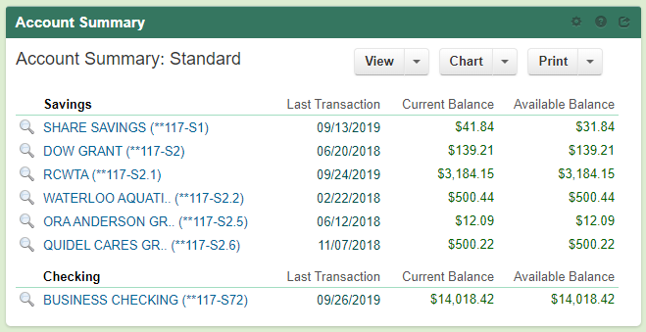

**Savings Account Summary:**

All accounts stayed the same as the prior month except for the RCWTA account. There were $82.25 in donations received at the canoes during the Pawpaw festival for RCWTA.

**Checking Account Summary:**

See page 2.

Amy has the total amount we calculated making from the Pawpaw Fest on the Kayak Raffle. There are still funds in the the RCP Paypal account that need transferred to RCP checking. Some of these funds are from the Kayak Raffle for 2019, some are also from Kayak Raffle from 2018 and RCP camp 2018 that were not transferred.

Question: Is there a division in Kayak Raffle funds between RCP general account and RCWTA?

Sarah’s to-do list:

1. Update RCP sub-accounts to reflect current grants
2. Need to subtract Trailer Registration from RCWTA acct. and add to RCP Biz. Checking
3. Need to fill out paperwork to get microscope $ from OU

**Checking Details since last report (8/22/19 – 10/2/19):**

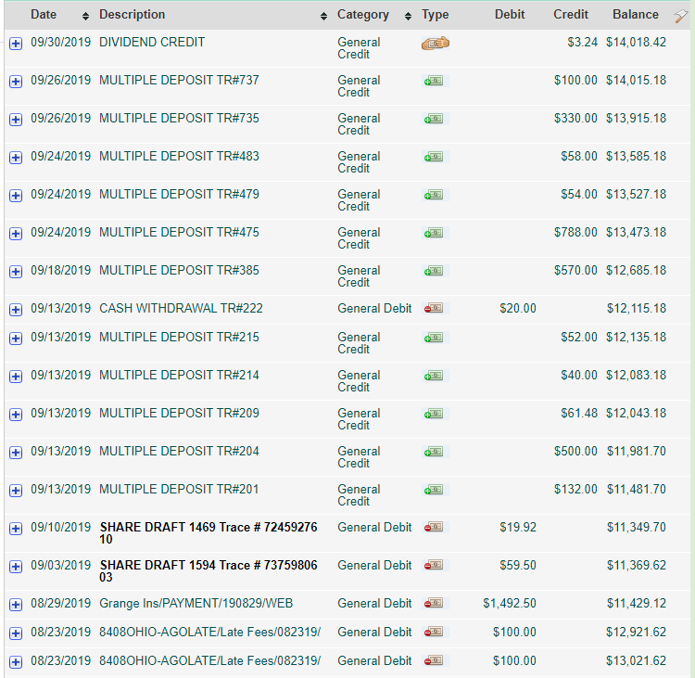

Membership

Raffle Tix

Donations

Merch sales

Pawpaw 2

2 Molly Students Pawpaw day admission

General Mills

Camp Shirts

Kroger Rwd

Raffle Tix

Pawpaw 1

RCO Tix

Nikki Reimburse

Trailer Reg.

Annual Insurance

2016 & 2017 OH Atty. General Late Fees