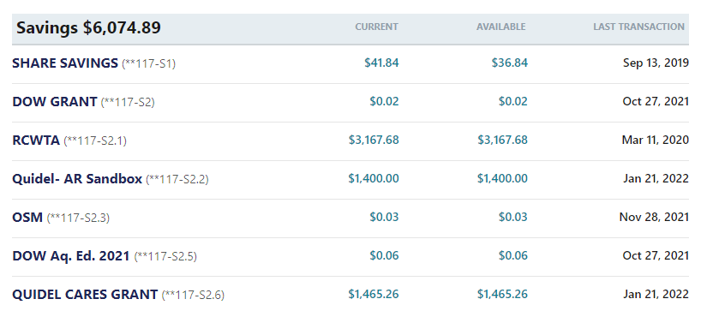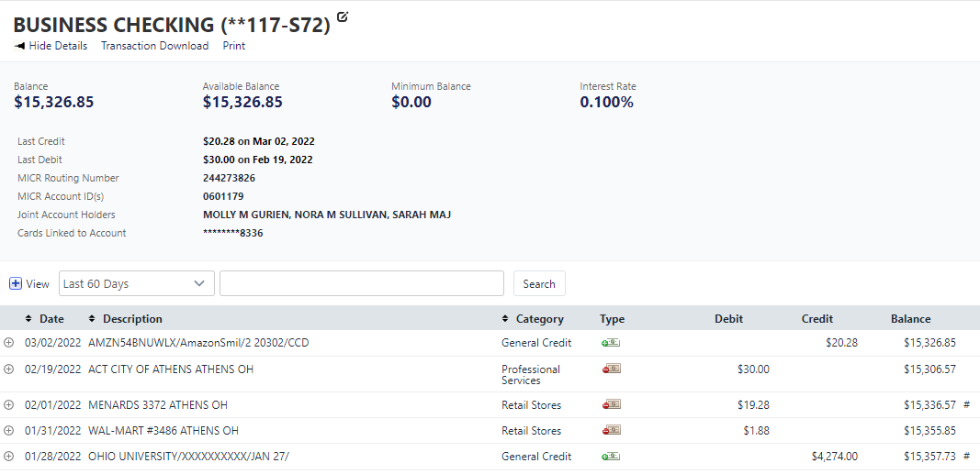Raccoon Creek July Meeting

Thursday, July 28th, 2022 at 6:30 pm

Present: Kelsey Daniels, Ashley Grace, Nora Sullivan, Amy Mackey, Chris Kimmel, Emily Keil-Loudner, Kelly Love, Sarah Maj, Kate Blyth

Minutes scribed by: Emily Keil-Loudner

* **Action Items**
  + AmeriCorps
    - Check to see if Amy has followed up about Aquatic Ed grant
    - Post about kayak and duck dash (once date decided) on Facebook
    - Make post about the official EWH and WWH designation on Facebook
    - Check with Zaleski about having duck race at Moonville Rail Trail
    - Do trail duck race down Hewett Fork
  + Kelsey
    - ask Raccoon Creek Outfitters if they have a heated meeting facility
  + Emily
    - Find official law that names Raccoon Creek as EWH and WWH
  + Not designated to anyone
    - Send out by-laws for all board members to sign
      * board members who were attending in person already signed
    - Need to ask Molly what day she prefers to help with canoes and how many people she can bring
* **Secretary’s Report**
  + Chris moves to approve last month’s minutes
    - Nora seconds
    - All approve
* **Treasurer Report**
  + reimbursed Molly for kayak
  + paid Rural Action for AmeriCorps then got reimbursed by OU
  + $500 Step Outside Grant went to Family Outdoor Day
  + did the Ohio Business Filing
    - only have to do once every 5 years
    - Chris moves to approve Treasurer's report
      * Nora seconds
      * all approve

Quidel Cares Grant:

* + 6/27: Menards Supplies ($87.93)
  + 6/27: Trailer ($924.69)

7/16- Speedway (Summer Camp Ice)

7/15- Speedway (Summer Camp Ice)

7/15- Ohio Business Filing (Secretary of State)

7/14- Speedway (Summer Camp Ice)

7/13- Walmart (Summer Camp Food)

7/13- Speedway (Summer Camp Ice)

7/13- Mama Renies Pizza (Summer Camp)

7/12- Mama Renies Pizza (Summer Camp)

7/11- Kroger (Summer Camp Food)

7/11- JoAnn Stores (Summer Camp Supplies)

7/10- Zonez (Summer Camp Patches)

7/7- Walmart (Summer Camp Food)

6/30- Amazon (Summer Camp Supplies)

6/30- Amazon (Summer Camp Supplies)

6/30- Check to Musician from RCP Celebration

6/30- Payment to Rural Action for Americorps Match

6/30- Amazon (Summer Camp Supplies)

6/30- Amazon (Summer Camp Supplies)

6/30- Amazon (Summer Camp Supplies)

6/29- OU Reimbursement for Rural Action Americorps Match

6/27- Reimbursement from Quidel Cares Grant for Menards Supplies

6/27- Reimbursement from Quidel Cares Grant for Menards Supplies

6/21 Amazon (Summer Camp Supplies)

6/15- Kayak Reimbursement to Molly

6/14- Check to Musician from RCP Celebration

6/13- Check to Musician from RCP Celebration

**6/05- Speedway (I am assuming Ice for Family Outdoor Day)**

6/4- Menards Supplies (Reimbursed from Quidel Cares Grant)

**6/3- Walmart (??? I am assuming Family Outdoor Day supplies)**

6/1- JoAnn Stores (Ink Stamp)

5/31- Trailer reimbursed from Quidel Cares Grant

5/31- $500 Deposit (Step Outside Grant)

5/27- Amazon Smile

5/23- Amazon (Family Outdoor Day)

5/22- Amazon (Family Outdoor Day)

5/21- Genesis Archery (Family Outdoor Day)

5/20- Precision Imprint

5/20- Amazon (Family Outdoor Day)

5/16- Deposit (Memberships)

5/12- OAG (Charitable Law)

**5/9- Walmart (???)**

5/6- Carnivalsource (Ducks)

5/3- Deposit (Memberships)

* **AmeriCorps Update**
  + haven't received word about aquatic education grant
    - Maybe need to follow up?
    - AmeriCorps, check with Amy to make sure she hasn't followed up yet
  + Summer Camp went well
    - learned things to approve on for next year
    - Treasure hunt activity went really well
  + Paw Paw Festival
    - will need volunteers
* **Fundraising Updates**
  + Kayak sales?
    - AmeriCorps will need to check
  + Duck sales
    - 28 ducks sold
    - haven't posted online until we have a date
    - AmeriCorps, post about kayak and duck dash (once date decided) on Facebook
  + Family Outdoor Day
    - went really well, had about 90 people
  + Celebration
    - it was fun but not well attended
    - need to keep trying to have events down in Gallia county
    - 18th of July was when legally Raccoon Creek was designated as Exceptional Warm Water Habitat (EWH) and Warm Water Habitat (WWH)
    - AmeriCorps, put the official designation on a Facebook post
      * Emily, find the law where its officially official
* **Upcoming Events**
  + Duck Dash
    - location: near Moonville Tunnel
    - originally thinking of having at first Raccoon Creek crossing on Rail Trail bridge but concerned about debris
    - AmeriCorps, will need to check with Zaleski about having race there
    - do we want to have it on video?
      * Yes
      * Chris has drone
      * could always see if OU student would be interested
      * have a GoPro
        + Ducks Eye view
    - Do we want spectators?
      * Depends on location if there is good place to watch
    - Could move location down to Hewett Fork
      * only one Rail Trail Bridge crossing up
      * would give spectators a chance to walk some of the rail trail and promote the rail trail
      * Plenty of room for spectators
    - Date: Sunday, September 25 at 2 PM
      * Chris moves to set date for duck dash to Sunday, September 25 at 2 PM
      * Nora seconds and all approve
    - AmeriCorps, do trail run at Hewett Fork
  + Paw Paw Festival
    - Date: September 16, 17, 18
    - \*\*\*\***Kate willing to be point person\*\*\*\*\*\***
    - Need to ask Molly what day she prefers to help with canoes and how many people she can bring
    - make sure to bring cash box
      * will bring square but needs Android phone or dongle to work
    - See if Glenn wants to bring canoes to and from Paw Paw (Chris will be out of town)
    - Depending on volunteers, maybe only do one day of canoes (Saturday)
    - Should see if Rocky and Sarie Landers want to help with canoes
  + Annual Meeting
    - plan on in person
      * will be potluck
    - Could promote progress with Scenic River designation or present Maxwell's Findings
    - Could have Matt Smith or Bob Gable come to speak
    - *Updated August 2nd, 2022* Board Members:
      * Kate, Kelly, Nora, Sarah and Chris were all elected in 2021
      * Emily is up for re-election
        + This will be last term before terming out
      * Molly is up for re-election
      * See if Glenn Stout would like to join board again
        + was on board but termed out, would be allowed to run again due to taking a year off the board
    - Location:
      * Kelsey, ask Raccoon Creek Outfitters if they have a heated meeting facility
* **Watershed Coordinator Update**
  + doing fish and bugs in Sunday and Monday Creek
  + Scenic River Update (given by Nora)
    - Matt Smith is still keeping up with our progress
    - Maxwell, grad student working on Raccoon Creeks Scenic River designation, defends his project next week and will have it finished up by end of summer
    - we could use his data for Scenic River report
* **New Business**
  + Next Meeting: Thursday, August 25th
  + Kate moves to adjourn
    - Emily seconds
    - All approve