Raccoon Creek March Meeting
Thursday, March 3rd, 2022 at 6:08 pm
Present: Kelsey Daniels, Ashley Grace, Nora Sullivan, Amy Mackey, Chris Kimmel, Emily Keil-Loudner, Kelly Love, Sarah Maj
Minutes scribed by: Emily Keil-Loudner

- Action Items
  - Nora and Sarah
    - Tax stuff
  - AmeriCorps
    - Send out ideas for newsletter articles
    - Send out sign up for Spring Day camp, FOD, and summer camp volunteers
- Secretary’s Report
  - Emily moves to approve last month’s minutes
    - Nora seconds
    - All approve
- Treasurer Report
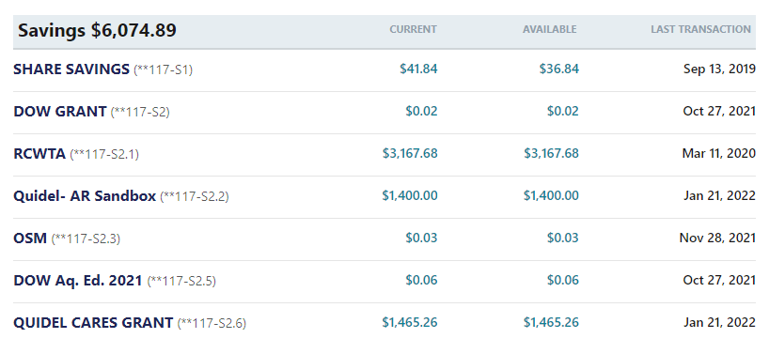

- No changes from last report

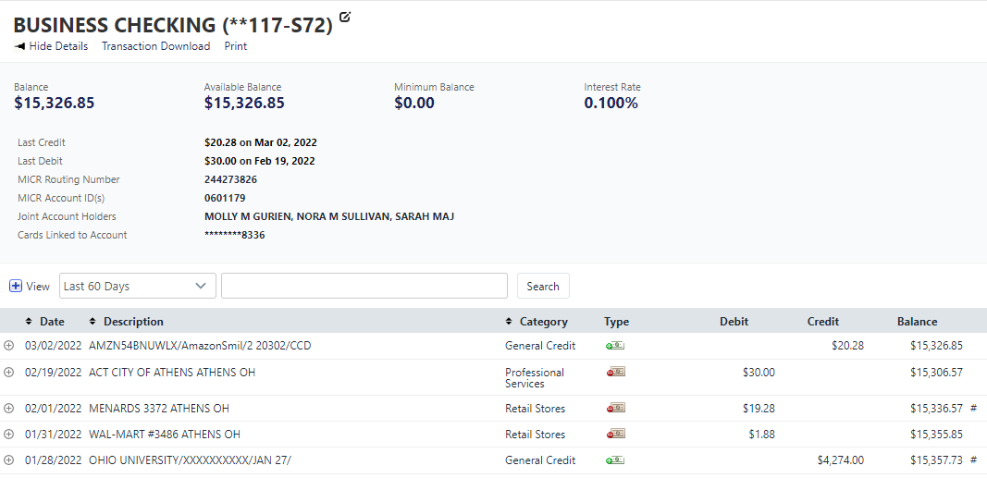

1/28/22: $4,274- OU Reimbursement for Americorps Match
1/31/22: $1.88- Walmart- Cotton balls for Owl Prowl
2/1/22: $19.28- Menards- Masks for Owl Prowl
2/19/22: $30.00- City of Athens- Shelter house reservation for Spring Day Camp
3/2/22: $20.28- Amazon- Amazon Smile deposit
  - OU reimbursed AmeriCorps match
  - Nora and Sarah – do tax stuff
- Watershed Coordinator Update
  - ID’s dead bugs
  - Catch up sampling
  - No apple grafting this year because we forgot
  - Met with Levi Arnold (New ODA Watershed Manager
    - He has lots of experience with outreach
    - Willing to come to a board meeting
  - For Family Outdoor Day, need new location for fish shocking and archery
    - They are doing maintenance on dam
- AmeriCorps Update/Upcoming Events
  - What date do you need articles for newsletter by?
    - March 20th
    - AmeriCorps – send out email with ideas for newsletter articles
  - Grants
    - Had a grant written up, and now it’s gone
    - Working with IT to find it
  - Owl Prowl
    - Had it last week
    - Decent turn out despite rain and reschedule
  - Appalachian Expo
    - March 19
  - Spring Day Camp
    - April 30th at Dairy Lane Shelter House
    - Wildflower hike
    - Pond study with macros and amphibians
    - AmeriCorps, send out sign up for volunteers
  - Family Outdoor Day
    - Need volunteers for intro, craft, fishing, and canoeing
    - Kaylin will help with canoes
    - AmeriCorps, send out sign up for volunteers
  - Summer Camp
    - July 11-15
    - Sign-ups starting March 18th
    - Suggested donation of $75
    - First 2 days are members only
    - Need volunteers
  - Duck Dash
    - Talking with Ellie from Captina Creek
    - We can borrow ducks but would have to get back to them after May 15th
      - Too close
      - Maybe wee if we can do after, maybe in the fall?
      - Ashley, ask Ellie we she got her rubber ducks?
      - Maybe do it next year?
    - Should we do it?
      - Three “Yes’s”, one abstain
    - Board agreed we can do it, will form a committee for the planning
      - Committee Meeting with be March 24th instead of a board meeting
  - Shirts
    - Zonez lost our original order and couldn’t resubmit the order
    - Put order into precision imprints
      - Also cheaper
  - Doser Channel Cleaning
    - March 14th at 10 am
- Operations
  - Watershed Upgrade Announcement
  - What’s the hold up?
    - We are trying to get Raccoon Creek designated as Scenic River but another watershed wasn’t prepared and a lot of misinformation was spread
    - Could use this announcement to get good news and good feelings for when we continue for Scenic River designation
    - Want to have political candidates hear how great Raccoon Creek is
  - Needs to happen fast
    - Doesn’t need to be really involved
    - Ribbon cutting for Creek’s upgrade
  - Could do at Vinton Dam
    - There’s a big shelter house
    - Committee: Chris, Nora, Kelly
  - Have food trucks
    - Chris may have lead for local ones
  - Look into have it in May
- New Business
  - Next meeting will be a committee meeting of the Celebration Announcement Committee at 6 PM and Fundraising Committee at 7 PM on March 24th
  - Have Levi Arnold come to committee meetings?
- Nora moves to adjourn
  - Emily seconds
  - All approve

