Raccoon Creek November Meeting
Wednesday, January 27th, 2022 at 6:15 pm
Present: Kelsey Daniels, Ashley Grace, Nora Sullivan, Amy Mackey, Chris Kimmel, Emily Keil-Loudner, Kate Blyth, Kelly Love, Molly Gurien
Minutes scribed by: Emily Keil-Loudner

- Action Items
  - Nora
    - Plan Fundraising Committee meeting with Chris and Kate
  - Board
    - Sign bylaws
    - Send articles for newsletter for AmeriCorps
  - AmeriCorps
    - Talk to Elkin about getting calendar on website
  - Chris
    - Email names of people who are [large agricultural] landowners next to Raccoon Creek to Amy
- Nora Update
  - Never did a roll out for an EPA upgrade and should do that because of Scenic River stuff
  - It would be really good to get the word out about the watershed before the Scenic Rivers stuff resumes
  - Needs to be a board thing
    - Amy can provide any information we need
  - We need to figure out how to get the word out about Raccoon Creek being “Exceptional Warm Water” habitat
    - Need to invite political figures
  - Will be in fresh everyone’s mind when we start talking about Raccoon Creek becoming a Scenic River
  - Need a place to put our ideas:
    - Testing out Miro White Board
      - Had a few hiccups
      - Maybe next time we are all in person, Chris can show us
      - Maybe we will just stick with Google Docs
    - Molly thinks we need press releases
      - Problem with Covid is we can’t do in person events right now
      - Virtual stuff doesn’t reach a lot of people
      - Places like Columbus Dispatch
    - Maybe plan an outdoor event maybe in the spring
      - especially during an election year, political leaders are more likely to come out
      - Need to make sure to invite landowners who have been a part of this too
    - Kate is making a Google Doc for us to put ideas
- Secretary’s Report
  - Nora moves to accept November minutes as is
    - Kate seconds
    - All approve
- Treasurer Report
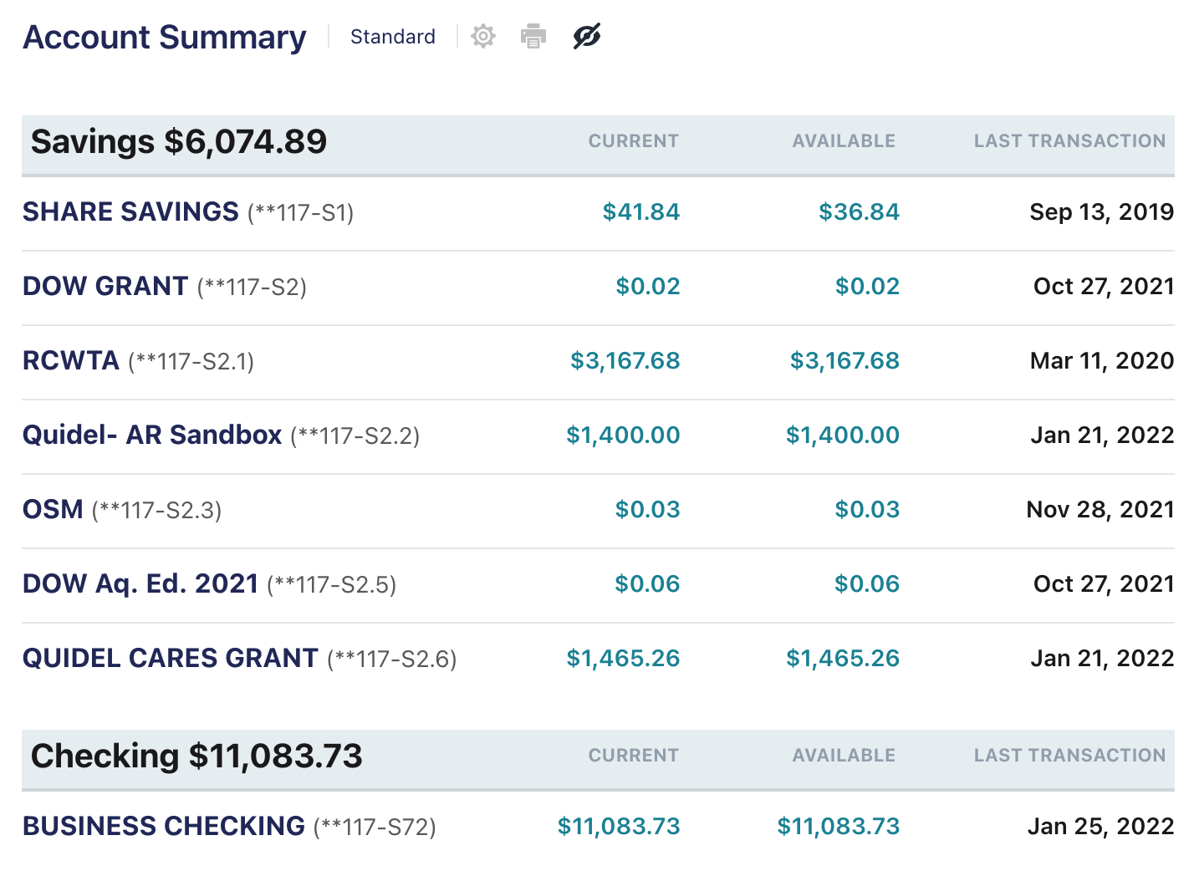

A new account was created for the $1,400 from Quidel for AR sandbox
Amy spent down all of the OSM funds, Go Amy!
Quidel Cares funds used to print new Water Trail signs

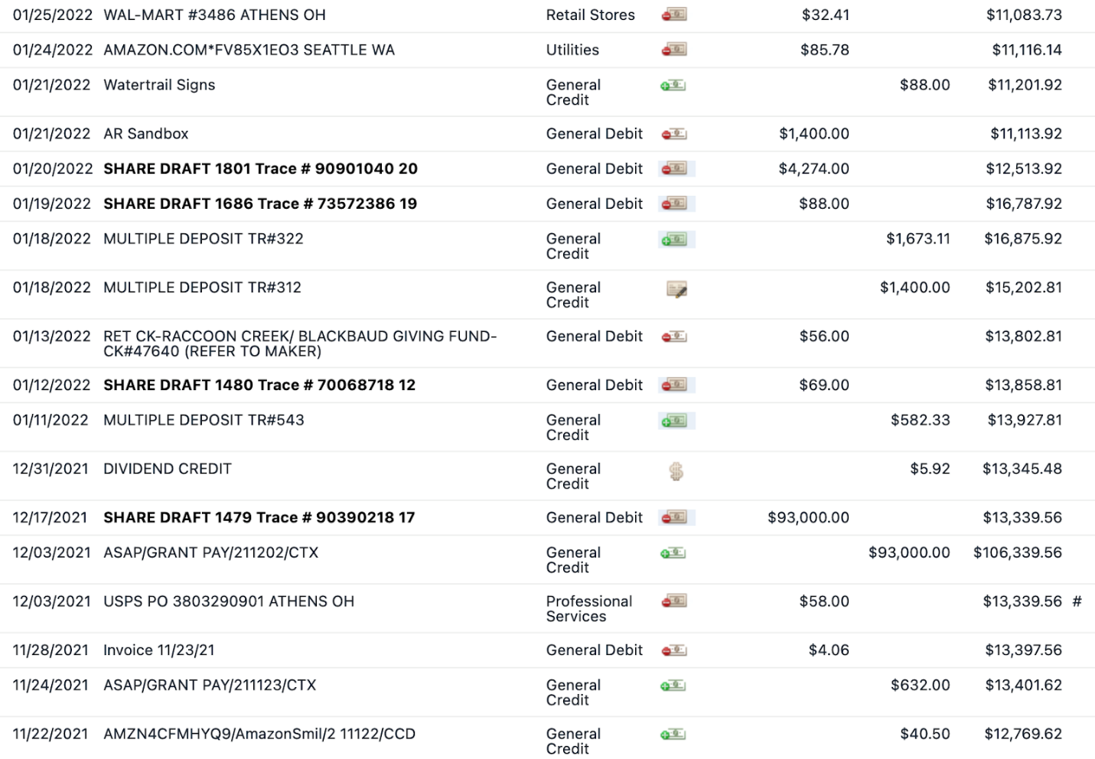

11/28: Invoice 11/23/21- Total invoice was $77.94 from Tractor Supply as Amy spent down OSM funds. The $4.06 was left over and taken from General

12/03: USPS PO - $58.00- Stamps for holiday letters

12/17: Division of MRM - $93,000- check for EBRC Steel Slag project

1/11: Deposit- $450 from Apple trees
$76.33 from Kroger
$56.00 from Blackbaud
$582.33 Total
1/12: Voinovich School- $69 - Website updates
1/13: Blackbaud canceled the check ($56.00)!
1/18: Quidel - $1400- AR Sandbox
1/18: $1,673 - Memberships and random donations
1/19: J-Fab- $88 - Water trail signs
1/20: Rural Action- $4,274- Americorps match Q1
1/21: Move AR sandbox money to its own account
1/21: Take funds from Quidel Cares account to pay for Watertrail signs
1/24: Amazon- $85.78- Owl Prowl pellets
1/25: Walmart- $32.41- Additional Owl Prowl supplies

- Asked Jen about AmeriCorps funds and she doesn’t see it being an issue in the next few years for Voinovich paying the AmeriCorps match
- Chris moves to accept report
  - Molly seconds
  - All approve
- Watershed Coordinator Update
  - East Branch Steel Slag Leech Bed maintenance project
    - Amy and AmeriCorps and ODNR went out to check on it
    - Going out to do sampling once the creeks thaw
    - The Steel Slag Leech Beds are discharging alkaline water
  - Scenic River project was put on hold
    - Apparently over the Paint Creek thing now
    - Some Scenic River guys went out to Raccoon Creek 1/26/22 to check it out
    - The director wants to designate a creek and thought Raccoon Creek would be a good fit
    - Program will no longer need counties or townships need letter supports
      - Trying to make it less political
    - Matthew wants us to come up with a list of landowners (preferably large agricultural landowners)
      - Amy is going to talk to Soil and Water groups
      - Landowners have to be along the creek
      - Chris already knows a couple
        - Chris, email names of people to Amy
  - New reclamation project
    - No longer funded by H2Ohio funds
    - Still happening, just not by those funds and happening in 2023
  - Infrastructure Funding
    - Ben McCamet said Ohio is getting $40 million/year for the next 15 years
      - Not clear what these funds are for
      - Goal is to reduce public health and safety projects related to abandoned mines
        - i.e. high walls
        - possibly allowed for reclamation projects
      - More funds going to Voinovich to allow Amy and Nora to do more acid mine drainage projects
  - Working on 9 element plan for the subwatershed around the Vinton Low Head Dam
    - Finally approved!
    - If we ever get landowner approval, we have a plan in place
  - Meeting with Levi Arnold next Friday and show him the projects
    - New ODA watershed manager for Southeast Ohio
  - Analyzing biological data
- AmeriCorps Update/Upcoming Events
  - Owl Prowl
    - February 3rd!
    - Working on take home kits (120!)
      - 4 libraries had people sign up
    - Have all supplies
    - May not need any volunteers
  - Grants
    - Step Outside
      - Looking to use to fund for Family Outdoor Day
      - Possibly new archery materials
      - food
    - Aquatic Education Grant
      - summer camp
        - backpacks and notebooks
        - hoping to do macro day, canoeing day, archery day
  - Duck Dash
    - Contacted about borrowing ducks
      - We can borrow them but they are going to need them back before there Duck Dash, which is in June
      - Thinking April or May
      - Going to go to Moonville to scout out good place for Duck Dash
  - Water Trail Signs
    - Got ahold of Eric Davis in department of transportation
      - Sent him GPS locations and PDF of sign
      - He is looking into it for us
  - T-shirts
    - Talking to Zonez for shirts
      - 20 shirts $24.95 each
      - 50 shirts $16.95 each
    - Ashley will look into cheaper options
    - Queensboro out of North Carolina generally has good prices (Chris uses them for his store)
  - Spring Newsletter
    - If have an idea for article, send to AmeriCorps!
  - Spring Camp
    - Day thing looking at aquatic insects, amphibians, etc.
  - Still doing Raccoon Creek Explorers
  - Going to schools on Thursdays
  - Ideas for Family Outdoor Day
    - Need to decide if we are going to have food
    - We have done Kaisers in the past
      - Emily looked into them for annual meeting and felt it was more expensive
    - If we decided to do food, Amy will need to check to make sure we can still do food
  - Appalachian Expo
    - AmeriCorps are signed up to go to that
    - Saturday March 19
  - AmeriCorps, maybe try to put calendar on website with upcoming events?
    - Talk to Elkin about calendar
- New Business
  - Future Meetings: 4th Thursday of each month for meeting
  - Try to sell new t-shirts on website
  - Need to work on marketing RCP better
  - Could use drone to fly over sites and use in marketing
  - Once weather gets nicer, have meetings at places other than OU
  - Talking with Assistant Professor of Biology & Wildlife Conservation at Rio Grande
    - Would like to have for talks or programs
  - Meeting adjourned at 7:44 pm

