Raccoon Creek Board Meeting
Thursday, September 2nd, 2021
Action items in red
Present: Emily Keil-Loudner, Amy Mackey, Sarah Maj, Molly Gurien, Chris Kimmel, Nora Sullivan, Glenn Stout, Kelsey Daniels, Ashley Grace
Minutes scribed by: Emily Keil-Loudner
Quorum established at 6:43 PM.

- Action Items
  - Sarah Maj - contact DOW about Step Outside Grant not getting deposited within 90 days, contact OEC about process to file verified complaint
  - AmeriCorps - put blurb on Facebook for Kroger Community Awards and Amazon Smile, send list of boats and waders to Amy and put registration stickers on canoes, ask Rural Action AmeriCorps to help with Paw Paw
  - Emily
  - Nora - send Sarah OEC contact info
  - Molly - look into and get kayak from REI for raffle

- Previous Minutes
  - Need to approve past two months minutes
  - Sarah moves to approve
  - Nora seconds
  - All approve
- Treasurer’s Report
  - Aquatic Education Grant
    - Ashley and Kelly working on final report
    - $1254 left over
    - Will ask Sean Landen to see if we can use funds on something else or give it back
      - Need: pH strips or small generator
      - Chris moves to buy generator if we can use the money towards it
        - Nora seconds
        - All approve
      - It needs to tie to an event
        - Could be used for Moonville
        - Note 10-6-21: Moonville was cancelled
      - DOW needs contacted because of Step Outside Grant didn’t get deposited within 90 days
        - Sarah Maj will contact DOW
  - All apple trees from Apple Tree Fundraiser gone!
  - AmeriCorps – put blurb on Facebook for Kroger Community Awards and Amazon Smile
Account Summary:
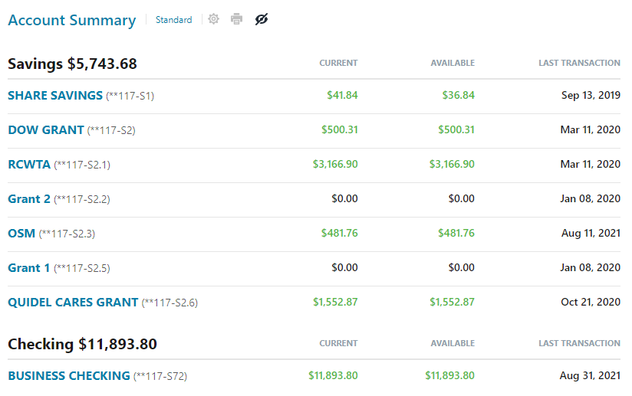

Business Checking Summary:
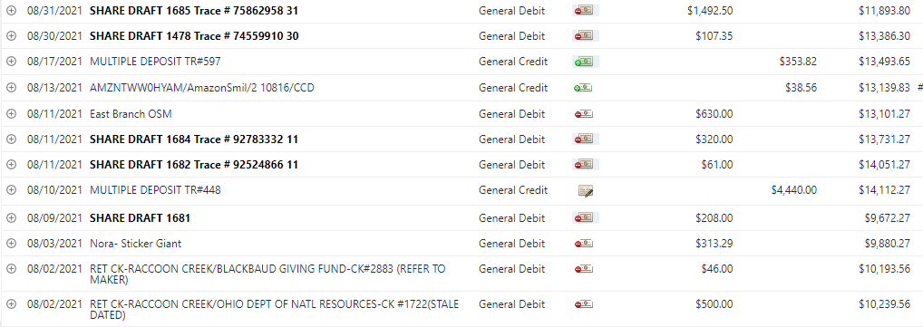

  - Deposits:
  - 8/10/21: $4,440- ODNR Aquatic Education Grant
  - 8/13/21: $38.56- Amazon Smile
  - 8/17/21: $353.82 Total ($125 cash (apples/memberhsip) $228.82 checks ())

  - Withdrawls:
  - 8/3/21- $313.29- Refund for Nora’s Sitcker Giant purchase
  - 8/9/21- $208.00- Zonez (summer camp patches)
  - 8/11/21- $61.00- Trailer Registration
  - 8/11/21- $320- Canoe Registration
  - 8/11/21- $630.00- East Branch OSM grant transfer (paid $148.30 from this account to Amy for various field work supplies)
  - 8/30/21- $107.35 refund Kelly Love for summer camp supplies
  - 8/31/21- $1,492.50 Insurance
- Watershed Coordinator Update
  - Lots of people contacted Amy to see if we had apples left
    - We do not
    - Derek Mills contacted Amy saying he would do it next year and do a workshop
    - Need to send him Thank You card
  - We got a new truck for sampling!
    - 2017 F150
    - Thank you Voinovich!
  - Sampling: down to only the boat sites (8 sites need boat)
  - Route 328 situation
    - Talked to Attorney General, US EPA still under investigation
    - Ohio EPA not allowed to sample
    - People are allowed to call EPA
    - Amy tried to get MBI to do a verified complaint but they said it needs to be from a citizens group
    - RCP did send complaint to direct of EPA
    - Site 16 miles downstream are way lower than in 2016
    - Going to sample Creek Rd, which is a boat site
      - It smells and is still greasey
    - RCP needs to do a verified complaint
      - Need to contact Ohio Environmental Council
      - Sarah Maj will contact OEC about process
      - Nora, send Sarah OEC contact info
      - Father of owner of A to Z sanitation went to prison for environmental crimes
      - Maybe contact Department of Health?
    - September 7th Ribbon Cutting of Moonville Rail Trail
- AmeriCorps Update
  - New AmeriCorps members!
    - Kelsey Daniels – just graduated with a degree in marine biology
    - Ashley Grace – AmeriCorps last year with Community Engagement
  - Chemical Sampling
  - Made activities for Raccoon Creek Explorers
  - Working on newsletter, waiting on articles
    - Amy will put something about ho w to report problems when you see them
    - Hold spot for annual dinner
    - Picture of Ribbon Cutting Ceremony
    - Sarah Maj has picture of Belgian Coke Ovens
  - In fall, do hike of new rail trails
  - Fall day Camp
    - Maybe end of September (actually, October 9th)
    - Hopefully in person but have a contingency plan
    - Thinking scavenger hunt/ fall hike with leaf rubbing
    - Possibly have a Ridges new trail!
  - Would like to do Midnight at Moonville
    - Called about how to register
  - Send list of boats and waders to Amy
  - Got 12 new dip nets and spray painted with fluorescent stripes
- PawPaw Fest
  - Glenn will take canoes to Paw Paw
  - AmeriCorps need to go to RCO and put stickers on and inventory life jackets
  - Molly check if Rocky wants to help
  - Need 2 people at all times for canoes
  - Americorps, ask Rural Action AmeriCorps to help
  - Molly will look into and get kayak from REI for raffle
  - Chris’s store will sponsor paddles and life vest up to $100
  - Ask Sarah Landers if she wants to volunteer
- Annual Dinner
  - RCO said we can use their shelter house but would have to move the date earlier
  - Also have to consider Covid
  - May want to have it outside, which means would want to have it in the afternoon
  - Could have it at Vinton County Airport shelter house
    - Has garage doors that open
    - Tables and chairs
  - Could do Sunday October 10
    - If Midnight at Moonville isn’t crazy
  - Have Glenn ask about October 10 and 17
  - Check with RCO about these dates and Vinton County Airport a plan B
  - Amy, have to see if RCO will have tables and chairs
  - AmeriCorps, start collecting donations for silent auction
  - No potluck, maybe catering?
    - Emily, call places to see if they cater and pricing for 50-75 people
  - Update 10-6-2021, board decided in email to not have in person annual dinner at this time. Will discuss more at next board meeting.

Meeting adjourned at 8:00 pm.

