Raccoon Creek November Meeting
Wednesday, November 17th, 2021 at 6:00 pm
Present: Kelsey Daniels, Ashley Grace, Nora Sullivan, Amy Mackey, Chris Kimmel, Emily Keil-Loudner, Kate Blyth, Kelly Love
Minutes scribed by: Emily Keil-Loudner

- Action Items
  - Nora
    - Send out bylaws to board members to sign
    - Plan Fundraising Committee meeting with Chris and Kate for December
  - Amy
    - Ask ODNR for invoice for OSM grant
  - Emily
    - Write Quidel grant for new computer for Augmented Reality Watershed Sandbox
  - Chris
    - Do a demo of Electronic White Board or Google White space and show us at next meeting
  - Ashley
    - Make new shirt design
  - AmeriCorps
    - Plan event to get people to put Water Trail put in and take out signs
    - Get in touch with Glenn and Molly about Water Trail signs
    - Get in touch with Ellie from Captina Creek about doing duck race
    - Write Step Outside Grant (and Aquatic Education Grant?) for events such as Family Outdoor Day or Summer Camp
  - All board members
    - Sign bylaws
    - Collect round pinecones for AmeriCorps
    - Do board hike at Moonville Tunnel
- Treasurer Report
  - 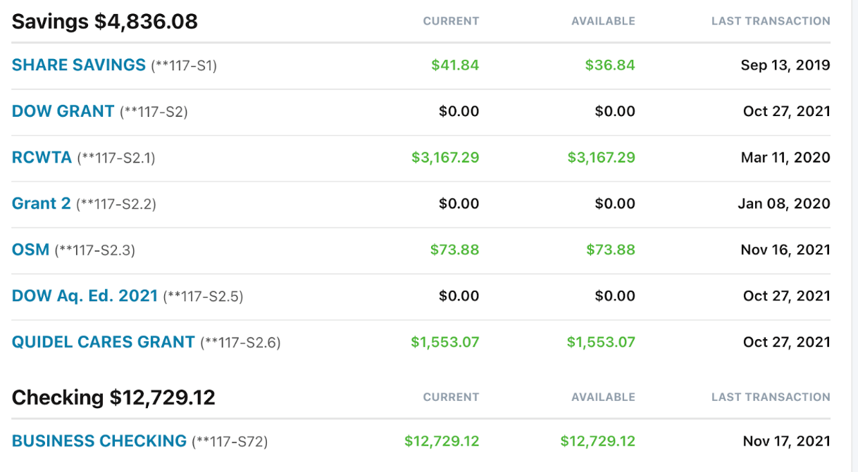
  - 11/10/21- Genesis Education Pellet- $153.00- What is this transaction? Should it come from general? Does someone need repaid?
  - We have been fully reimbursed for the Americorps match and the steel slag project as of today!
  - Amy has been working on spending down the OSM money and is getting very close, on $73.88 left in that account.
  - Please, in the future if everyone who is seeking reimbursement create a simple invoice indicating all refunds and from which sub-accounts they should come out. If you are not sure which account, please ask! Also please include photos of the receipts for whatever purchases you made.
    - Amy has blank invoices that if anyone needs reimbursement, it makes things a lot easier for Sarah
    - Also could take picture of receipt and what it is for
  - Amy, ask ODNR to invoice OSM grant so can get money out of account and write up final report
    - Spending down grant, needs to have everything out by December
  - Nora moves to approve last month’s meeting minutes
    - Chris seconds
    - All approve and motion passes
- Board Position Elections
  - Nora, send out by laws to board members.
  - Board members, sign bylaws and send back to Nora.
  - Nominations for board positions
    - Chair: Chris Kimmel
    - Vice Chair: Nora Sullivan
    - Treasurer: Sarah Maj
    - Secretary: Emily Keil-Loudner
  - Nora moves to elect positions as shown on ballot
    - Emily seconds
    - All approve and motion passes
- Action Planning
  - Quidel Cares grant application due soon
    - Emily, write up Quidel grant for new computer for the Augmented reality sandbox
  - Still have money from previous Quidel Cares grant
    - Grant was written up for canoe event but Covid happened
    - Used to renew registration on canoes
    - Could use for new tires, wires and straps for canoe trailer
    - Chris moves to have professional put new tires and wires on canoe trailer
      - Nora seconds
      - All approve and motion passes
  - Lets take winter board hike to Moonville!
    - Allows the board to see new bridges put in
  - Would like to see Water Trail canoe put in and take out signs put up
    - AmeriCorps, have event to get people to put signs up
    - Some locations have had issues getting permission
    - Other locations (like Zaleski SF), have had permission in the past
    - AmeriCorps, get in touch with Glenn and Molly
    - Figure out where the signs need to go
    - Get permission
    - Make into event
  - Need Fundraising Ideas
    - Need corporate sponsorships, just don’t really know how to do that
    - Need presentation
    - Create committee for working on corporate sponsorships
      - Fundraising Committee: Nora, Chris, Kate
      - Nora, plan Fundraising Committee meeting for December
  - Fundraising Idea:
    - Do duck race at Moonville
    - AmeriCorps, talk to Ellie at Captina Creek
      - Ask if we could use their ducks
      - Ask what she would do differently
    - Plan duck race for June
      - Make sure to get special use permits at least 1 month in advance
  - With New Trails at Moonville, we could do bike race or Trail Runs
    - Kate has connections with Ohio Running Company
  - Could do nice map of Moonville Rail Trail and Raccoon Creek
  - Hopefully able to have Family Outdoor Day this year
- Watershed Coordinator Update
  - Doing another project!
    - H2Ohio funding unexpectedly became available and needed spent. They went to ODNR Mineral Resource Management and asked if they had any projects
    - Project between Illesboro and Harble Griffin
    - Reclaiming 27 acres of abandoned ridgetop surface mining
    - Draining 2 pits
    - Amy is going to do some sampling there
  - No updates on A to Z sanitation situation
  - Holiday Mailing goes out after Thanksgiving
  - Vinton Low Head Dam
    - Met with landowners
    - Talked about some possibilities
    - Landowners not in any hurry to make any choices
    - Amy met with Bill who does Low Head Dams in Northeast Ohio
      - Gave Amy some next steps
      - Such as Funding for preliminary sampling
        - This is something that can be done and even if its 30 years from now, will be useable and one thing off the to-do list
    - Possible community pressure about keeping dam
    - Supposedly people have died at the dam but can’t find any records
    - Landowners asked us to set up at Bean Dinner and do a fish demo in August
    - We will be doing it
  - Scenic Rivers
    - On hold-ish
    - Maxwell still working on criteria and what parts of Raccoon Creek will be designated
    - Scenic Rivers Folk asked us to lay low
      - Issue in Paint Creek Scenic River process
      - Some misinformation went around and farmers in uproar
    - Scenic Rivers Folk want to update the language in the Ohio Revised Code before moving forward on any Scenic River projects
- AmeriCorps
  - Updating membership list
  - Uploading meeting minutes
  - Created Holiday Card
  - Amy needs to do letter for Holiday Mailing
  - Helping Kelly with her Master’s Project
    - Studying macroinvertebrates to become level 2 certified
  - Planning Owl Prowl
    - Contacting Lake Hope about how many people are allowed
      - **Update 11/28/21** Number of people allowed: since we are not catering, limit is the room capacity, which is 100
        - Kaylin is happy to help
        - New Owl expert is Jeff Large, he would be happy to help and has a Great Horned Owl
    - Could do a hybrid Owl Prowl
      - If limited by number of people, have activity packets for people not there and distribute to local libraries again
    - Need new presenter, Pat Quackenbush retired
    - Could also look into moving to different location
      - Possibly Gallia county next year?
    - Need round pinecones for craft
      - Could also buy scented cones after Christmas for discounted
- Upcoming Events
  - Owl Prowl
  - Family Outdoor Day
    - Ask about outdoor events at Lake Hope
      - The last one was at Lake Hope and was extremely successful
      - Could look at other places as well
  - AmeriCorps, after first of year, write Step Outside Grant (and Aquatic Ed grant if you want)
  - Celebration of Recovery of Raccoon Creek
    - Invite Public Officials
    - Big Party!
  - Ashley, Make new shirt design
    - Emily suggests with a paddlefish
  - Appalachian Expo
    - March
  - Farm City Days in Gallia County
    - Usually in Fall
  - Soil and Water Conservation District Meetings
    - Used to go to those
    - Would like to start going again
- Other Business
  - Electronic White Board
    - Or Google White Space
    - Better way to stay connected between meetings
    - Chris, do a demo and show us at next board meeting
  - Next Meeting:
    - Thursday, January 27th at 6:30
    - The Ridges Building 22
  - Meeting adjourned at 7:52

