Raccoon Creek Board Meeting
Wednesday, March 24th, 2021
Action items in red
Present: Nora Sullivan, Emily Keil-Loudner, Amy Mackey, Chris Kimmel, Matt Davis, Ashley Smith, Kelly Love, Molly Gurien, Sarah Maj
Minutes scribed by: Emily Keil-Loudner
Quorum established and meeting started at 6:34 PM.

- Overview of action items
  - Sarah - ask Sarie what DOW grant for $500, ask Sarie how to do charitable registration and taxes
  - Amy - look into what the Quidel grant was for (canoe related items), email Heike Perko to see if she has compost for grafting, get in touch with Shannon about spreading good word about scenic river in Vinton
  - Nora - look into canoe and trailer registration stuff
- Review and Approve prior board meeting minutes
  - Molly moves to approve meeting minutes from last month
  - Matt seconds
  - All approve and motion passes
- Treasurer’s Report
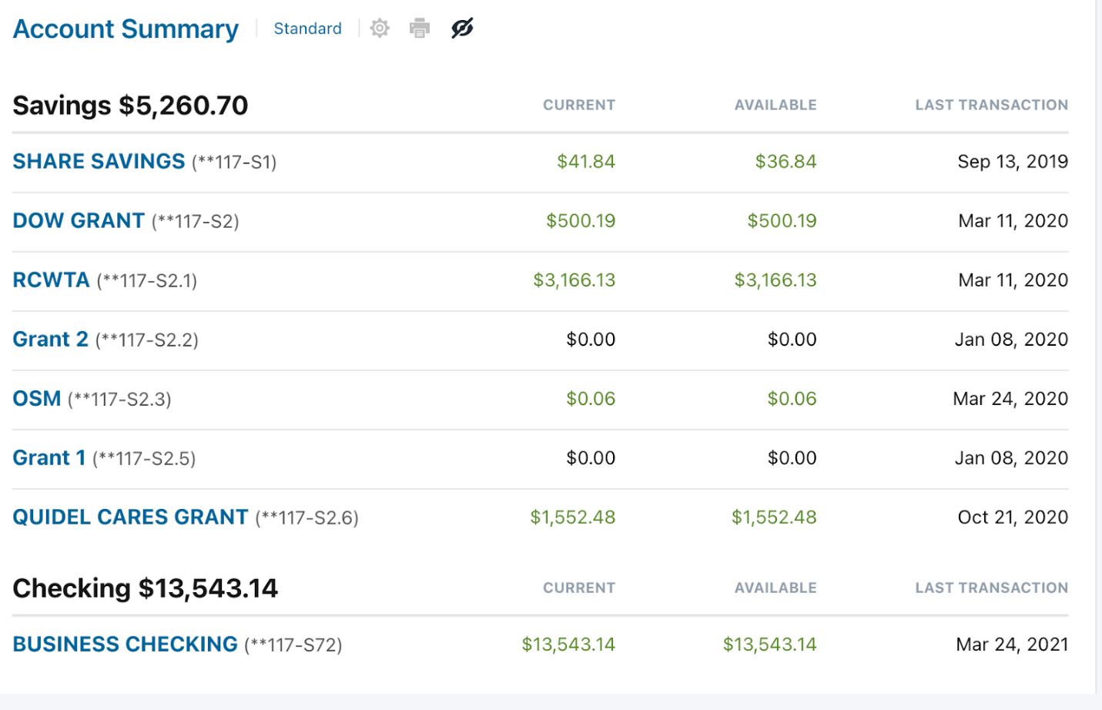
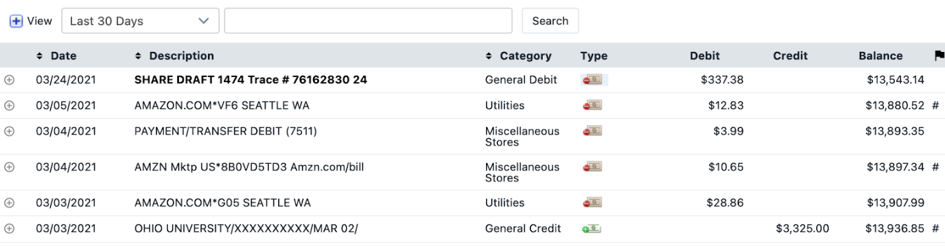
  - Amazon items are for items for spring day camp activity kit and summer camp kit. Test items to make sure things are quality items.
  - Payment for website update
  - Sarah, ask Sarie what DOW grant with $500
  - Amy, look into what the Quidel grant was for (canoe related items)
  - Nora, look into canoe and trailer registration stuff
- Watershed Coordinator Update
  - Ohio EPA study plan
    - Was approved!
    - Guide for next two years of chemical and biological sampling
  - Apple grafting
    - Ordered 100 root stock and came in last week
    - Derek Mills will pick them up and get them started
    - Rural Action just had a tree planting and gave Amy all the pots
    - Glenn donated money for pots, but will email Glenn to see if we can hold onto it in case we need other supplies
    - Amy has to go to Logan to pick up scions
      - RCP will reimburse Amy for the mileage
    - Amy – email Heike Perko to see if she has compost for grafting
  - Rush Creek sampling
  - Division of Forestry guy brought drone to photograph Moonville bridge project
  - Student (Maxwell) working on Scenic River project
  - Chasta, student working on 9 element study plan for low head dam in Vinton
  - We are recruiting for AmeriCorps, Ashley and Kelly are moving to bigger things!
    - If you know anyone, have them contact Amy directly, we can start interviewing immediately
- AmeriCorps Education Update
  - Ashley shared drone pictures of bridges being built as part of AML project
  - Applied for Step Outside grant
    - Step Outside grant for kits similar to Owl Prowl Kit
    - Want to make 200 kits
  - Applied for Aquatic Education Grant
    - Supply 30 campers with backpack of activities
    - A week of self-guided activities
      - The week after or weekend after, family activity somewhere with canoes
    - Day at Raccoon Creek Outfitters does not qualify under the grant
      - Looking for alternatives, may use our canoes
      - RCP could also help funding
  - Ohio River Sweep
    - Need to find a location
    - Could do Buckeye Furnace again if can’t find a new spot
    - Maybe do somewhere in Hocking County, such as Ilesboro
  - Newsletter
    - Almost all the way done
  - Raccoon Creek Explorers
    - Post activity first Monday of the month
    - Have not heard any feedback
    - It appears people are participating though
- Charitable Registration/Taxes
  - Sarah, ask Sarie how to do
- Scenic River
  - Chris working on getting letters of support for scenic river
    - Doing an awesome job getting several letters from different townships!
  - Amy, get in touch with Shannon about spreading good word about scenic river in Vinton
- New Business/Announcements/Next Meeting
  - Next meeting Wednesday, April 21st at 6:30 pm
    - Try to do in person somewhere outside so Glenn can come
    - Nora check in on April 8th to determine locality
    - Lake Hope shelter house as back up
  - Nora moves to adjourn meeting
    - Matt seconds and all approve
  - Meeting adjourned at 7:44 pm

