Raccoon Creek Board Meeting
Wednesday, June 30th, 2021
Action items in red
Present: Nora Sullivan, Emily Keil-Loudner, Amy Mackey, Chris Kimmel, Matt Davis, Ashley Smith, Kelly Love, Sarah Maj, Molly Gurien
Minutes scribed by: Emily Keil-Loudner
Quorum established and meeting started at 6:32 PM.

- Action Items
  - Nora
    - have Maxwell come to next meeting
    - register canoes
    - check license of trailer
    - keep checking website for reservations for PawPaw
    - reserve shelter near Ridges for next meeting
  - Kelly
    - look into if we have Amazon account and if this needs to be cancelled
  - Molly
    - send us dates for September that you are busy
    - look into pricing of kayaks
  - AmeriCorps
    - ask local stores (like Walmart) to see if they are willing to make a donation (for or towards a kayak)
    - work on posters for kayak raffle
  - Amy
    - ask Bob Gable and Matthew Smith if preference for weekday or weekend for canoe float
- Molly moves to accept last month’s meeting minutes
  - Nora seconds
  - All approve
- Treasurer’s Report
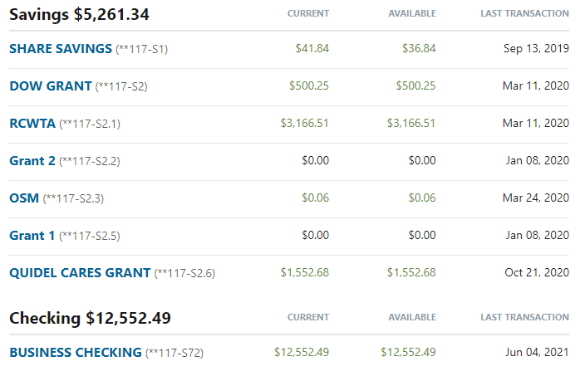
  - There was one withdrawal from the checking account on 6/4/21 for $3.99 for the Amazon Subscription. This is a recurring monthly transaction. May be accidental subscription, need to look into.
    - Kelly will look into if we have Amazon account and if this needs to be cancelled
  - Deposits will be made once the OUCU account is updated with current board members.
- Watershed Coordinator Update
  - Biological monitoring
    - Sandy Run fish and macroinvertebrate sampling is done!
    - East and West Branch, Hewett Fork, and first main stem Raccoon Creek done with macroinvertebrate
    - Finished biology in Rush Creek
    - Sampling is working around rain
  - Meeting with Bob Gable and Matthew Smith
    - Matthew Smith Northeast Ohio Scenic Rivers Coordinator and now Southeast Ohio Scenic River Coordinator
    - Nora have Maxwell come to next meeting
    - Need to get a “Steer Committee” together
      - Help secure collaborators and cooperators
      - Talk about what angles that will help secure acceptance of making Raccoon Creek a scenic river
    - Bob Gable and Matthew Smith want to do a float!
  - Working on 9 element plan for watershed around Vinton low head dam
    - Land owner is interested and willing to listen to our ideas
  - Have AmeriCorps for next year!
    - Ashley and Kelsea
    - Voinovich School will pay for parking permits again
      - Also paying entire member match
    - Supervisor meeting next week to go over final details
- Water Trails
  - Nora register canoes
  - Haven’t been active this year due to covid
  - Need to determine if we are going to have canoes at PawPaw but depends on if we have the people to work it
  - Would love to have a float for the Scenic Rivers people
    - Could do a regular fall float
    - Or could just take them out as a small group of us (may be better idea)
      - Amy said she would come!
      - Maybe board members and maybe a few others
        - Like asking the Hoys
    - Plan small group float for Scenic Rivers people
      - No later than October
      - Lets plan for beginning of September
      - Amy, ask them if preference for weekday or weekend
      - Molly, send us dates for September that you are busy
      - Nora, check license of trailer
- AmeriCorps Update
  - We got the grant!
    - Got $4,500 to get things for summer camp
    - Can start buying things tomorrow (July 1st)
    - Have 2 open spots
    - 2 emergency spots
    - Would still like to do a float on the Saturday of camp
      - Raccoon Creek Outfitters
        - Short Trip: $960
        - Long Trip: $1260
      - Could also do Lake Hope float
        - If do this route, need to get approval soon
        - Would also want Kalyn Callendar so they won’t charge us or make us get special use permits
      - Age group is 2nd through 6th grade
        - Maybe 2nd graders too young to be on Raccoon Creek
      - Would be a lot of coordinating
        - Getting boats there
        - Enough adults with kids
  - Ashley has been doing data entry and facebook posts while doing MBI internship
- Other Business
  - Molly has a bunch of hand painted signs in garage, would like to put in storage at Ridges
    - Will take pictures and send pictures to Amy
    - If don’t need them, can get rid of
- PawPaw Fest
  - Molly will call Rocky to see if he can help with boats
    - Will also ask Sarie if she can help with boats
  - Amy will be out of town and cannot help at all
  - Kelly and Ashley are welcome to come help too
  - In years past, board has bought wristbands for volunteers
  - We have not been gifted a kayak
    - Do we want to buy a kayak to raffle off?
    - We have spent $300-$350 in the past
    - There is a high demand for kayaks and are more expensive
    - Molly will look into pricing of kayaks to see if its worth it
      - Should ask Raccoon Creek Outfitters because they are a kayak dealer – see what is the cheapest kayak we could get
    - AmeriCorps, ask local stores (like Walmart) to see if they are willing to make a donation
    - Chris’s store, Twisted Specialty, can sponsor $100 toward something
  - Nora, keep checking website for reservations for PawPaw
  - Chris moves to allot $500 for kayak
    - Nora moves to table this at a later time
  - AmeriCorps, work on posters for kayak raffle
- Banking Update
  - They are processing the paperwork
- New Business/Announcements/Next Meeting
  - Next meeting date:
    - Wednesday July 28th
    - Will decide location at later date
    - Nora, reserve shelter near Ridges for next meeting
  - Meeting adjourned at 7:34 pm

