Raccoon Creek Board Meeting
Wednesday, July 28th, 2021
Action items in red
Present: Emily Keil-Loudner, Amy Mackey, Matt Davis, Kelly Love, Sarah Maj, Maxwell (student working on Scenic Rivers project)
Minutes scribed by: Emily Keil-Loudner
Quorum was not established, not actions were voted on. Meeting started at 6:51 PM.

- Action Items
  - Matt - see if Dustin has any used kayaks in cheap-ish zone
  - Emily – send out email about Paw Paw festival and other events
- Treasurer’s Report
Account Summary:
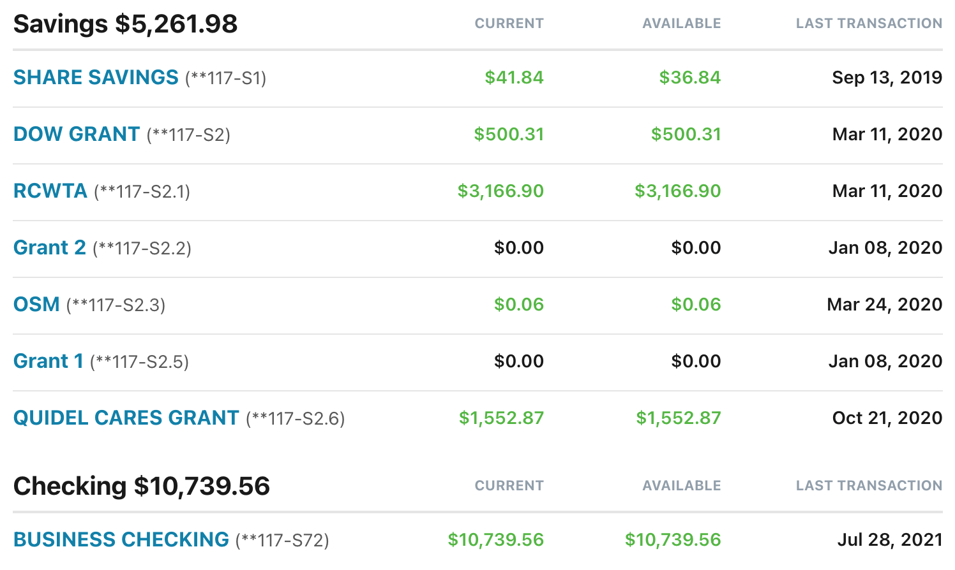
- Business Checking Summary:
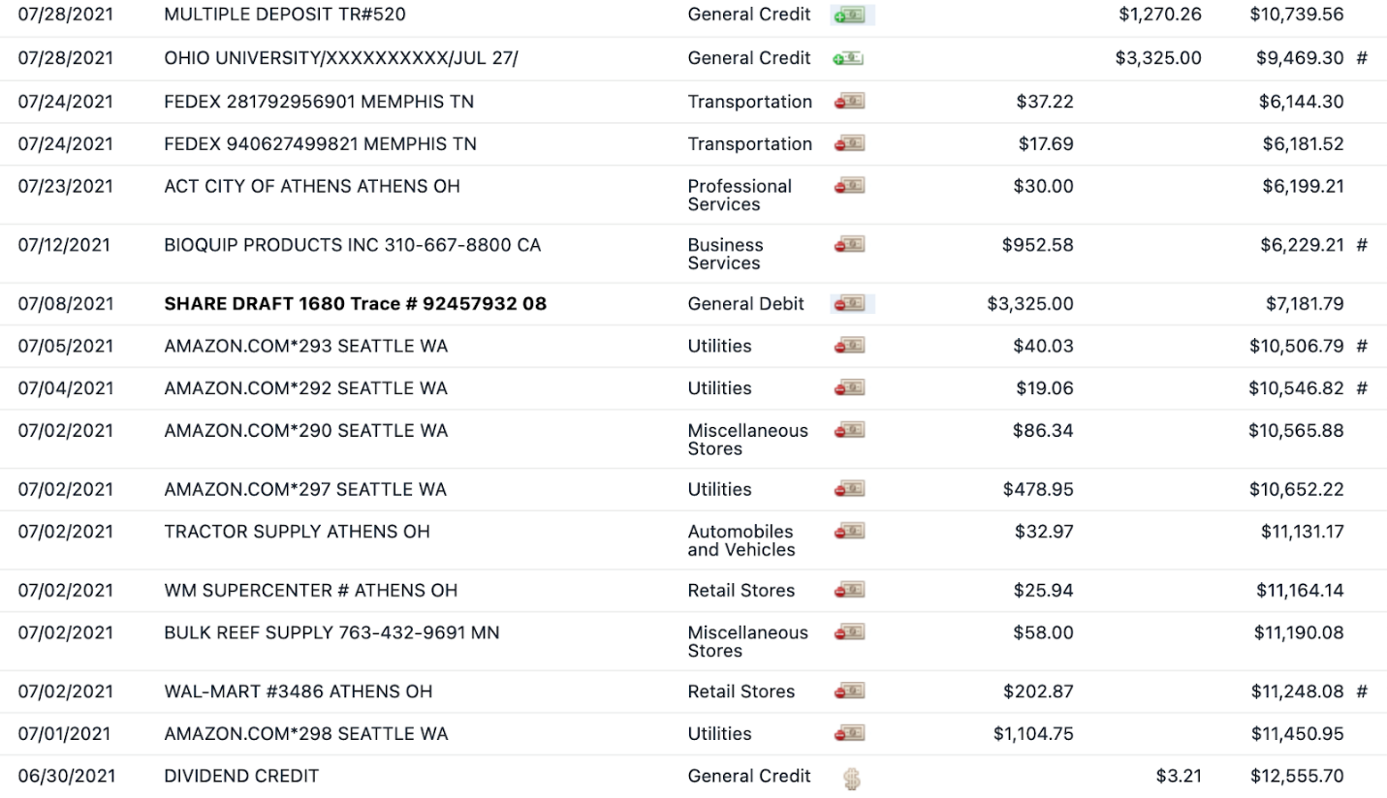
- Deposits:
- 7/28/21- OU Americorps funds
- 7/28/21- Cash: $45 from tshirt sales + $58 general donation = $103 total
- Checks: $15 tshirt + $200 general donations + $100 apple trees + $225 membership fees + $500 ODNR + $81.26 Kroger + $46 Blackbaud Giving Fund = $1167
- Total: 1270.26
- Withdrawals:
- 7/1/21- Amazon Supplies purchased for Summer Camp
- 7/2/21- Walmart Supplies purchased for Summer Camp
- 7/2/21- Beef for Summer Camp
- 7/2/21- Tractor Supply Supplies purchased for Summer Camp
- 7/2/21- Walmart Supplies purchased for Summer Camp
- 7/2/21- Amazon Supplies purchased for Summer Camp
- 7/2/21- Amazon Supplies purchased for Summer Camp
- 7/4/21- Amazon Supplies purchased for Summer Camp
- 7/5/21- Amazon Supplies purchased for Summer Camp
- 7/8/21- Americorps money
- 7/12/21- Bioquip Nets
- Need More Information:
- 7/23/21- ACT City of Athens
  - Charge for reservation of shelter house
- 7/24/21- Two FedEx charges
- There are a few reimbursements that will need to be made. Not all receipts have been submitted, so this will need to be addressed during the meeting (Zonez embroidery for $208?, Kelly mentioned two Walmart receipts but only submitted one, need FedEx receipts, Nora reimbursed for stickers ($313.29))
- Watershed Coordinator Update
  - Poop in Raccoon Creek
    - A2Z sanitation has permit along 328
    - They were violating permit with amount applied and a slew of other things
    - It is impacting a significant portion of Raccoon Creek
      - Visible signs of grease, dissolved oxygen (DO) low as 0.8 (minimum for fish is 4.0) up to 9 miles downstream
      - No fish kills reported but are probable
    - General Mills cut off all contracts with A2Z
    - A2Z supposed to be helping clean up
      - They have boons for collecting grease and are supposed to siphon off the grease
    - Though it is the year to do biology in Raccoon Creek, they have not done biology in sites impacted
      - Been sampling in Little Raccoon and way downstream of impact
    - **Update on 8/15/21**
      - Site 15 miles downstream of A2Z permit show initial biology scores significantly lower than in 2016 in both fish and macroinvertebrate communities
      - Board drafting letter to OEPA expressing concerns and questions about situation
  - Sampling
    - Little Raccoon Creek MAIS sampling complete
    - All of Leading Creek, Rush Creek and Sandy Run have fish and bug sampling completed
    - Working on MAIS sites in main stem of Raccoon Creek
  - Other updates
    - Natalie Kruse working on funding for Amy and Nora to help with getting Raccoon Creek a Scenic River
    - Sean Lambert notified Amy of fish kill in Sunday Creek near Cornstill Rd
    - Bobbie Hoy’s mother passed away – board sent condolence card
    - Ben McCament, former Raccoon Creek Watershed Coordinator and currently working at ODNR Mineral Resource Management, his wife passed unexpectedly – board sent condolence card
    - ROAR registration came in
      - Saturday October 30th
      - Registration due September 24th (no fee to register)
      - **Update on 8/15/21** Board agreed to participate in ROAR, Amy sent in registration
    - Captina Creek Festival
      - October 16th
      - Asked RCP to attend with stream table
    - Buckeye Trails Blue Blazes Festival
      - October 1 and 2nd
      - Could set up table
    - Midnight at Moonville
      - October 9, 3-12 pm
      - Have set up tables in past
    - Amy talked to Matthew Smith at AOWC meeting
      - They want tour of watershed and float
      - Once they give Amy dates, she will let board know
- AmeriCorps Update
  - Bought stuff for camp
    - Need to pay for backpack patches
  - Summer camp went great
    - Self-guided
  - Have extra back-packs, about 5 or 6
    - May raffle them off
- PawPaw Fest
  - Amy and Matt can’t attend
  - Board needs to figure out if they can feasibly attend
  - **Update 8/15/21**
    - Enough of board is willing to work shifts making it feasible to attend with booth
    - Nora registered us
  - Matt, see if Dustin has any used kayaks in cheap-ish zone
  - Emily, send out email for Paw Paw and other events
- Annual Dinner
  - Should do in-person meeting if possible
  - Need to determine possible date for annual meeting
  - Could do it earlier (normally first weekend in November) and have at Raccoon Creek Outfitters shelter house

