Raccoon Creek Board Meeting (Zoom)
Wednesday, October 21st, 2020
Action items in red
Present: Nora Sullivan, Emily Keil-Loudner, Chris Kimmel, Amy Mackey, Ashley Smith, Charles Sterling, Sarie Cornwell
Minutes scribed by: Emily Keil-Loudner
Quorum established and meeting started at 6:35 PM.

We have guest, PhD candidate at Virginia Tech, Charles Sterling.
Ethics class with Mark Edwards
looking at Acid Mine Drainage in Southeast Ohio
dilemma of problems of the past being paid for in the present
i.e. current coal companies pay for remediation of historical acid mine drainage.
How can we help?
Interviews (such as community members)
Opinions of the governments role and how we got involved and progress so far
- Overview of action items
  - Nora - look into other options for meetings (instead of Zoom)
  - Sarie - renew registration for trailer, OUCU account updates (needs to be done ASAP)
- Review and Approve prior board meeting minutes
  - Sarie moves to approve minutes
  - Chris seconds
  - All approve
- Treasurer’s Report
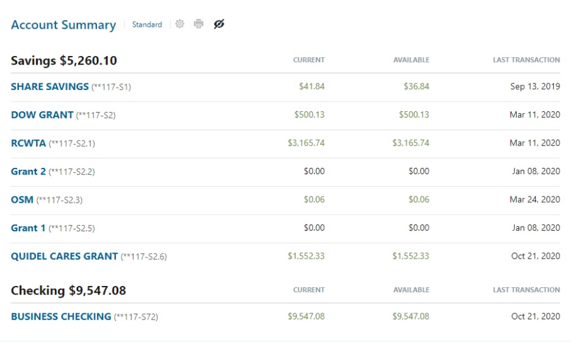
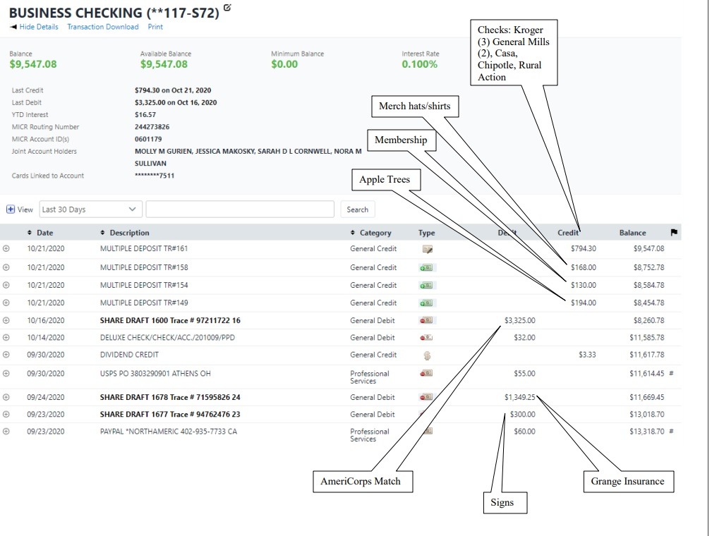
  - Savings finally deposited Quidel Cares grant into own sub account
  - We got another OSM grant (EB slag bed rehab project)
    - Amy get number to Sarie
  - Deposited several checks
    - Chipotle
    - General Mills
    - Casa
    - Kroger Rewards -$100.10, $72, $67
    - Memberships -130
    - Merchandise – t-shirt and hats
    - Tree sale -$194
  - Sent check to Rural Action for AmeriCorps
    - Will be reimbursed by OU Voinovich School
    - OU doesn’t pay until end of quarter
  - Insurance came out
  - Nora and Sarie need to get together about account holders
    - Nora made motion to take Jessica Makosky off Ohio University Credit Union account and put Sarah Maj onto account
    - Emily seconds
    - All approve
  - Sarie not continuing as treasurer, so need another person on card holder
    - Nora needs to get a card since she is always at office
    - Keep Sarie on until Sarah Maj is trained
  - Sarie has vehicle registration renewal for trailer
    - Sarie will renew registration for trailer
- AmeriCorps Education Update
  - Lake Hope float didn’t happen (no events in the parks right now)
    - Will try again in the spring
  - Kelly applied for a Mountain Dew grant
  - Kelly needs ideas for historical areas around Raccoon Creek that hasn’t been highlighted yet on Facebook
  - Are giving education packets to young ones of Raccoon Creek
    - May use step outside grant
    - Hope to get Mountain Dew grant for
  - Kelly signed up for another month of non-profit tip donation at Casa
  - Newsletters done! Coming soon.
  - Invasive signs are up! At least 30!
  - Helping at fish biology demo for OU classes on Oct 27th
  - Helping Tuscawaras AmeriCorps with riparian buffer project
  - Helped with Apple tree sale
  - Helped with Field Methods class
- Watershed Coordinator Update
  - Got another Office of Surface Mining (OSM) grant
    - $100,000
    - For project construction and some admin and supply funds
    - This one rehabbing steel slag leach beds in East Branch of Raccoon Creek
    - $7,000 admin funds used to pay Amy and Nora to administration and water quality monitoring.
  - Issues with RCP website
    - Typically have grant funds to pay for IT people
    - Had to make motion over email to pay IT to fix and do updates
  - Pilot Funding
    - Abandoned Mineland Projects with Economic Aspect
    - Moonville Rail Trail is approved and happening
    - Broken Arrow project in beginnings
      - Would remove lots of acid forming materials in Flint Run
      - Add lime
      - Add outdoor recreation use (access, trails, canoe/kayak put-in, etc)
      - ODNR supportive of project
  - Catching up on sampling
  - Ilesboro post-reclamation tour
    - Typically at end of project, do a tour
    - Project was completed fall 2019, tour planned for spring 2020 and couldn’t do tour because of pandemic
    - Did a virtual tour of the site (story map)
    - Funders were really happy with it.
    - Current view count is 448, where if in person, maybe 12 people would attend.
  - Raccoon Creek Story Map
    - Large-scale story map
    - Will include completed projects and other watershed destinations (not just acid mine drainage projects), recreational areas, areas of concern, public land, historical sites
    - Starts at headwaters and goes through the entire watershed
    - Hopefully done in next month or so
    - Will try to get entered into story map competition by ESRI.
- Annual Dinner
  - Obviously can’t have in-person annual dinner
    - Required to have one in Bylaws
  - Will do virtual annual dinner
    - Maybe do public presentation
    - Someone walk everyone through the Ilesborro story map
      - Maybe if entire watershed story map done, we could do that.
    - Could push back date so we can show Raccoon Creek story map
    - Could make a scavenger hunt based on story map
      - With prizes!
    - Look at dates and times
      - When do we think story map will be ready?
        - ESRI competition deadline is November 25th
        - Could have something to be presented third week of November
      - Could limit to 1.5 hours
      - Should check with Caroline who is working on story map before setting date?
      - Maybe Friday, November 20th?
        - Date night with Raccoon Creek!
        - 6:30 – 8
    - Could do a recording
      - Cast to Facebook as a Facebook live
      - Sarie volunteered to do that
    - Could have multiple people present different sections
      - Amy do project sites
      - Kelly historical stuff
      - Chris Galliopolis stuff
  - To count as annual dinner we need…
    - Treasurer’s report
    - Elections
      - Survey Monkey?
      - Emily and Sarie up this year
  - Need nominations 2-weeks before election
      - We do need nominations!
      - Do Facebook posts!
      - Molly may be interested in coming back?
      - Put blurb in newsletter email about nominations.
      - If sticking with November 20th for meeting, need nominations by November 6th.
  - Could put little postcards in Newsletter about annual dinner and asking for nominations.
      - Putting newsletters out this week.
  - Plan meeting November 6th to plan more details about annual dinner.
    - Nora look into other options for meetings (instead of Zoom)
  - Memberships
    - Need membership current to vote
    - Say in newsletter that need to be current to vote and NEED to be at meeting
    - Due to pandemic, not everyone may be in financial situation to pay dues.
      - However, the bylaws state that to be able to vote in election, must be current member (meaning they have paid dues) to vote
      - Constitution does NOT say what the dues are
      - Possibly make dues for this coming year $0 and just state donations would be appreciated?
      - Table discussion about how to manage paying membership in light of pandemic
- New Business/Announcements/Next Meeting
  - Meeting November 6th at 6 pm for meeting to hammer out details for annual dinner.
Meeting adjourned at 8:15 pm

