Raccoon Creek Board Meeting
Thursday, October 3rd, 2019
Action items in red
Present: Amy Mackey, Nora Sullivan, Angie Cameron, Glenn Stout, Emily Keil-Loudner, Kelly Love, Ashley Smith, Jessica Makosky
Minutes scribed by: Emily Keil-Loudner
Quorum established and meeting started at 6:37 PM.
- Overview of action items
  - Nora
    - make map game with name the dots for annual dinner
    - get local chicken meal for annual dinner
    - ask Ed Shrider if he is interested in running for a board position
  - Amy
    - buy fish food to finish up NANFA grant
    - update most recent projects
      - Play film (Chad from OU made) at annual dinner
    - venison roast for annual dinner
    - send email to Emily with nominations you have received
    - ask Matt Davis about running for board position
    - Scott Moody to run again
  - Molly
    - ask Dustin about proof of purchase and donation form for Amy to sign
  - Sarah
    - Get $$ from OU for microscopes
    - Change account names
    - Ask Molly about differentiating RCP and water trail accounts of raffle funds

  - AmeriCorps
    - Post on Facebook a call for nominations
    - send Greg Guess (assistant chief of DOF) annual dinner invite
  - Emily
      - Coordinate with Annika for stuff
      - make sign up sheet for ROAR
  - Jessica
    - Pork carnitas for annual dinner
  - ALL
    - Gather donations for Annual Dinner Silent Auction
    - Don’t forget membership dues if running
  - Annual dinner MC
    - thank Broeckers and Hoys at dinner

- Treasurer’s Report
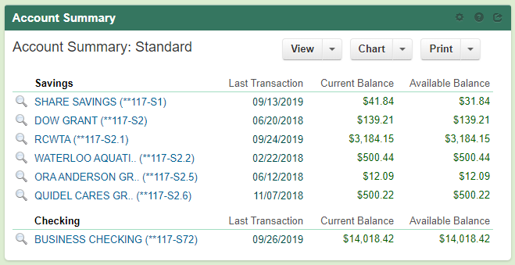
  - Presented by Ass. Treasurer
  - Amy, buy fish food to finish up NANFA grant
  - DOW account sand box and stream table
    - OU donated new computer for sandbox
      - Working on getting AR program set up
      - Just need to get new projector mounted to make sure the projector and computer can communicate properly
  - All accounts stayed the same except water trails $82 in donations from PawPaw
  - Raised $1790 from kayak raffle
  - Still funds in RCP paypal account that needs transferred
  - Ask Molly about differentiating RCP and water trail accounts of raffle funds
  - Received Kroger rewards check
  - Invoice $ Amy spent
    - Replacement water trail sign
    - Tools, camp stuff, etc.
    - $242.05
Checking Details since last report (8/22/19 – 10/2/19):
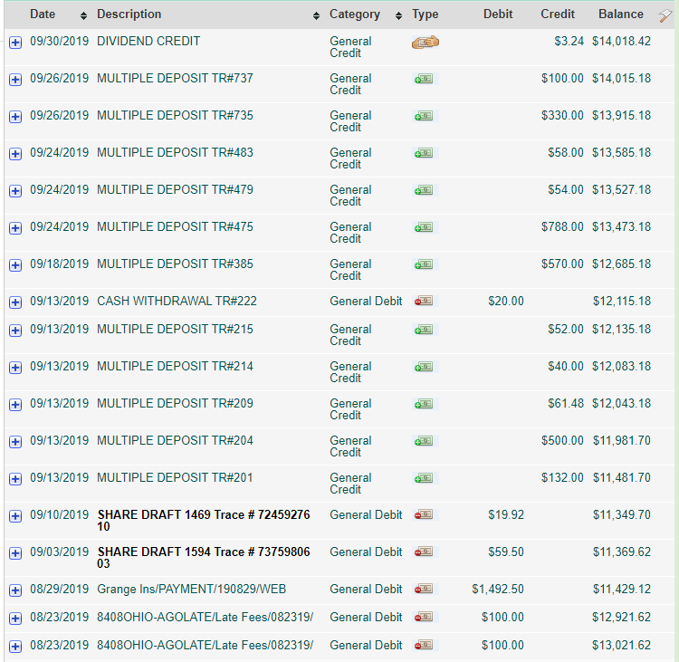
Nikki Reimburse
Trailer Reg.
2 Molly Students Pawpaw day admission
Membership
Raffle Tix
Donations
Merch sales
Pawpaw 2
General Mills
Camp Shirts
Kroger Rwd
Raffle Tix
Pawpaw 1
RCO Tix
Annual Insurance
2016 & 2017 OH Atty. General Late Fees

- Watershed Coordinator Update
  - Amy attended Vinton County Soil and Water Conservation District annual dinner
    - Met with assistant chief of Division of Forestry, said he will send RCP updates up the chain
    - Vinton County doing fish sale
    - AmeriCorps, send Greg Guess (assistant chief of DOF) annual dinner invite
  - Sandy Run project completely done
    - Brochure and poster (which will be hung up in Lake Hope Nature Center) are part of EPA 319 grant
    - Post construction public tour will be October 19th, after Lake Hope Fall Hike
      - Fall hike starts at 10 am, will be shuttling to site of dam removal after hike
    - Ohio Watershed Leadership (OWLs) conference happened in September
      - Did tour of Sandy Run low head dam
      - ODNR did fish shocking demo
    - Ilesboro still not done
      - Will have meeting soon
    - Working on chemical sampling
- AmeriCorps Education Update
  - Two educational programs last week
    - Science Fair night at West Elementary (outside McArthur)
    - Met with Kelly Capuzzi at South Elementary for “Learning in the Creek”
      - Had three stations set up: macroinvertebrates, water chemistry, fish shocking demo
    - Science Alliance
      - 3-day event
      - 15 minute speed dating for science
      - ~1500 high school students
  - Upcoming: Midnight at Moonville
- Upcoming Events
  - ROAR
    - October 26th, interior of Lake Hope Lodge
    - Emily in charge
      - Coordinate with Annika for stuff
      - Emily, make sign up sheet
  - Doser Channel Cleaning
    - October 31st at 9:30 am
  - Annual Dinner
    - Where: ODNR Zaleski Complex
    - Speaker: ????
      - John Boilegh
        - ODNR state archaeologist / Ohio Valley history
        - Amy call John
      - Bob Eichenberg?
      - Note for next year: Butterfly Ridge guy (unavailable this year)
    - Nora make map game with name the dots
    - Amy update most recent projects
      - Play film (Chad from OU made) at annual dinner
    - Jess, make pork carnitas
    - Amy, venison roast
    - Nora, get local chicken meal
    - Annual dinner MC, thank Broeckers and Hoys at dinner
- Board Nominations
  - Amy, send email to Emily with nominations you have received
  - Nora and Glenn rerunning
  - Still need 3 people
  - Nora, ask Ed Shrider?
  - AmeriCorps, make facebook post
  - Angie moved to extend nomination period to October 17th
    - Nora seconded
    - All approved
    - Will include blank space on ballots for write ins
  - Ask Scott Moody to run again?
  - Amy ask Matt Davis
  - Don’t forget membership dues if running
- Equipment Storage Update/INS
  - Almost all things moved from Broeckers (done as of 10/17/19!)
  - Insurance address has been changed
- New Business/Announcements/Next Meeting
  - Kelly Capuzzi nominated Raccoon Creek for the lower 40 miles to be classified as a Scenic River
  - Ohio Mineland Partnership (OMP) meeting October 15th and 16th near Zanesville
  - Next meeting: annual dinner on November 3rd
  - December meeting: Thursday December 5th, 6:30 PM at the Ridges, Building 22
  - Jess motioned to close
    - Nora seconded
    - All approved

