Raccoon Creek Board Meeting
Thursday, January 24th, 2019
Action items in red
Present: Jessica Makosky, Emily Keil-Loudner, Amy Mackey, Nora Sullivan, Sarah Cornwell, Annika Gurrola, Nikki Salas (and Benny), Molly Gurien, Max & Ashley (students in Molly’s marine biology class).
Quorum established and meeting started at 6:38 PM.
- Previous meeting minutes reviewed, motion to approve minutes, seconded and passed.
  - Reviewed last month’s action items
    - Amy and Jess need to meet about treasury stuff
    - Public meeting
      - Molly will follow up with Joe about bat presentation, depends on his funding.
    - Corporation of Non-profits
      - Asking for annual reports, which Molly filled out last year.
Nora will check to see if there is a template for annual report.
      - Possibility of back fees. Assets that are less than $20,000 has zero fees, but Amy’s $100,000 grant may affect this. Linda may be able to help, she used to do this for Rural Action.
    - **Nora update insurance stuff **

- Treasurer’s Report

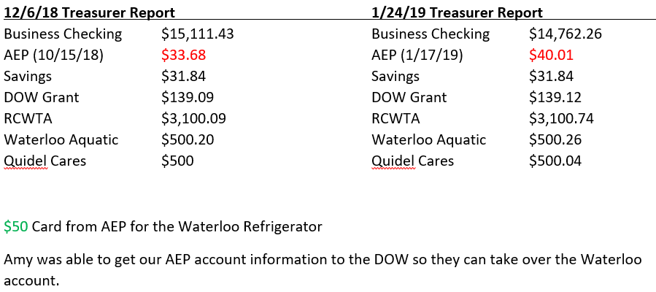

  - Update on accounts
    - Still need to pay Zonez and AmeriCorps
    - DOW
      - Water Education Grant
      - Used for sandbox items
    - Quidel Cares
      - From Quidel to put up educational signs about preventing spread of aquatic invasive species
      - Jennie working on getting locations to put signs, photograph localities and getting permission from corresponding agencies to put up signs
    - RCWTA
      - Used for gas, canoe and trailer registration for public floats.
      - In years past, RCWTA would transfer 10% to RCP account for administrative purposed, but since all part of RCP now, no need to do that.

- Watershed Coordinator Update
  - Working on entering data into system
    - All 2017 and 2018 water chemistry data entered and verified.
      - Nora working on the 2017-2018 Stream Health report
    - Working on biological data
      - Fish data not started yet
      - Working on macroinvertebrate ID
      - Bio must be complete by March 15
  - Amy had meeting with ODNR in January about sampling plan and has a meeting on Feb. 7 with ODNR about 2019 and 2020 sampling plan
  - Started recruiting for 2019-2020 AmeriCorps at Ohio Wildlife Management Conference
    - AmeriCorps applications open on February 1st
    - Interviews usually can start as early as April 1st

- AmeriCorps Update
  - Owl Prowl
    - Feb. 7 5:30-8 pm at Lake Hope Lodge
    - Used google doc to sign up to bring items/help out
    - AmeriCorps, contact Angie about TP rolls for owl project
    - Annika will confirm with Pat Quackenbush
    - Everyone needs to review Google Doc to see what they are bringing/doing
    - Glenn is putting up the RCP event signs
  - Spring Day Camp
    - April 27th, 10-2 at RCP Outfitters conjunction with Raccoon Creek outfitters opening
    - Nikki and Annika will be doing archery (both took NASP training)
  - Family Outdoor Day
    - June 1st at Lake Hope from 12-4 pm
    - Will finalize activities in the next week and coordinate with Amy to get permit.
  - Summer camp
    - July 15-19
    - Need ideas for locations, have thought about Racoon Creek Outfitters or Lake Hope
    - Annika and Nikki will get quote and check availability for both
  - Annika, Nikki, and Jennie will be going to almost all the Soil and Water Conservation District meetings in the watershed and will be giving presentation

- Water Trails
  - Molly will follow up with Glenn about signs
  - Hold boats for RAW camp for the following dates
    - June 11-13
    - June 18-20
  - Clean Sweep is June 15.
  - Jennifer Sommerville looking for canoe instruction for summer campers
    - Molly would be interested in doing an instructional course for those interested (Nora, Emily, Annika and Nikki are interested) and could allow Jen’s counselors to join.
    - Need to plan if doing instruction course, such as reaching out to any other interested AmeriCorps
    - Could write a Division of Wildlife grant to cover instructional costs
  - Interested in doing a group only float

- Waterloo
  - Trash items taken out! Most everything was out before Christmas.
  - Jess called AEP and took electric out of RCP’s name.
    - Fridge taken to AEP and received $50 card.
      - Will use for odd and ends use.
  - Annika and Nikki almost finished with inventory! Just need to inventory Division of Wildlife (DOW) shed and figure out what is RCP’s, Amy will help with this.
  - Amy emailed Ken Richie notifying that they were almost done, just need to do a few things in January, DOW needs to winterize Waterloo
  - Still a few water trails stuff (racks and bungee straps), display board, and Family Outdoor Day signs that need to be retrieved. Sarah and Molly will pick up water trail stuff and Family Outdoor Day signs.
  - Time to look at long term solution.
  - AS OF JANUARY 27TH RCP/RCWTA ITEMS HAVE ALL BEEN REMOVED FROM WATERLOO AND THE KEYS HAVE BEEN RETURNED TO DOW.

- Strategic Planning
  - Strategic planning meeting is set for Thursday, Feb. 28 at 6:30.

- New Business
  - Microscopes
    - Molly would like 4 compound scopes for school trip
    - Amy, Glenn and Annika are interested in the dissecting/stereo microscopes. RCP will keep one stereoscope
    - Motion made by Nora to sell microscopes:
      - University at $50/scope
      - Personal at $20/scope
    - Motion seconded by Jess and passed.

- Announcements
  - Wildlife Diversity Conference
    - March 5th in Columbus
  - Next meeting
    - Feb. 28th at 6:30
      - Potluck!

Meeting adjourned at 8:31 pm

