Raccoon Creek Board Meeting
Thursday, August 22nd, 2019
Action items in red
Present: Amy Mackey, Nora Sullivan, Molly Gurien, Sarah Cornwell, Angie Cameron, Glenn Stout, Emily Keil-Loudner
Minutes scribed by: Emily Keil-Loudner
Quorum established and meeting started at 6:33 PM.
- Overview of action items
  - Nora
    - Print canoe waivers
      - ~100 double sided
  - Amy
    - Waivers filed
    - Contact Chris Kline of Hocking County Butterfly Ridge as possible speaker for annual dinner
  - Molly
    - Check with Dustin about fall float (including workable date)
    - See if we can get more wristbands for PawPaw since need more workers for canoes
    - ask Dustin about proof of purchase and donation form for Amy to sign
  - Sarah
    - Reorganize accounts
    - Get $$ from OU for microscopes
    - Change address for insurance
    - Ask Jess to help haul things back to Voinovich on Sunday of Paw Paw
  - AmeriCorps
    - Change water trail borrower’s agreement
    - Post on Facebook a call for nominations
  - ALL
    - Articles for newsletter
      - Deadline September 6th
    - Think about people to run for board
    - Gather donations for Annual Dinner Silent Auction
- Review and Approved prior board meeting minutes
  - Angie moved to accept previous minutes
  - Molly Seconds
  - All approved
  - Motion passes
- Treasury Report/Bank account
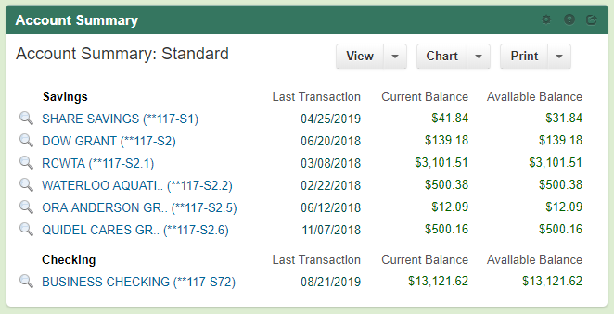

Checking Details last 60 days:
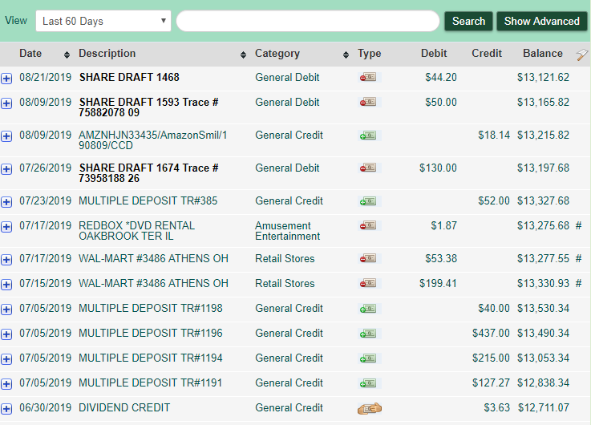
Memberships & Boat Rental
Microscopes
Pawpaw Booth Fee
RCO Canoe shuttle @ RCP camp
Shagbark for camp
Jess Deposit?
Creek Jam
General Mill & Kroger
  - Sarah
    - Reorganize accounts
    - $$ from OU for microscopes
  - Received $500 for Step Outside grant
    - Been spent and reported on
  - $12 for Rowan Calhoun’s camp shirt
  - Received letter about fees for Charitable Registration
    - Sarah already paid
  - Received trailer registration
  - Check to Nikki for $19.92 for first aid supplies
- Equipment Storage/Insurance Update
  - Sarah (or Nora)
    - Change address for insurance
      - Building 21, The Ridges, Athens, OH 45701
  - Still few things at Broeckers
    - Amy, Nora and AmeriCorps are going to get those
- Charitable Registration Compliance Update
  - Sarah submitted everything and paid all fees
    - Wrote letter and was able to get late fees reduced by $200
  - Saved digital and hard copies of Proof of Payment
- Watershed Coordinator Update
  - Monday August 26th, new AmeriCorps start, Ashley Smith and Kelly Love
  - Need RCP newsletter printed before PawPaw festival!
    - Deadline for articles September 6th
  - OWLs conference September 5 & 6th at Lake Hope
    - Amy doing tours
      - Sandy Run low head dam removal
    - DOW doing shocking demo
  - Sandy Run low head dam removal
    - It happened!
    - Division of Forestry did the removal
      - Labor part of 319 grant match
    - Going to plant trees on Tuesday
    - October 19th Lake Hope Fall Hike
      - Will have Sandy run tour
    - Poster at nature center
    - Sign at King Hollow Road
    - Brochure
  - August 6-8 Amy joined up with several agencies to do big head carp removal at mouth of Raccoon Creek
    - ~8 carp removed
    - Lots of paddlefish!
    - Got a blue catfish
    - RC bird pool is leading edge of big head carp
      - If numbers are kept low, this will slow their expansion upstream
- Upcoming Events
  - Paw Paw festival
    - Glenn bringing canoes and kayaks on Friday
    - Push raffle tickets for kayak at OWLs conference (haven’t sold nearly as many as last year)
    - Molly
      - see if we can get extra wristbands since doing canoes
      - ask Dustin about proof of purchase and donation form for Amy to sign
    - We get 4 weekend wristbands
      - 2 for AmeriCorps
      - Sarah and Eric
      - Glenn and Rocky
      - Molly’s students (usually buys one or two one-day passes out of water trails $$)
    - Sarah
      - ask Jess to see if she can help haul things back to Voinovich
    - Nora
      - Print canoe waivers ~100 double sided
    - Someone
      - Find “to do” and “to bring” lists
  - ROAR
    - Lake Hope on October 26th
  - Annual Dinner
    - Date: Sunday November 3rd
    - Speaker: Chris Kline of Hocking County Butterfly Ridge
      - Amy will contact
      - Bob Eichenberg as another possible speaker?
    - Location:
      - Laurel Lodge at Lake Hope
      - Vinton County Community Building
      - Wilkesville Community Building
      - Raccoon Creek Outfitters
      - ODNR Zaleski office
    - Elections:
      - Angie, Glenn and Nora up for re-election
      - Jess terms out
      - Need 1 nomination, if others run again
        - Emily will take nominations
      - Ask Scott Moody to run again
      - Ask Jess if she has anyone in mind
      - Everyone
        - think about people to run
        - start gathering donations
      - Newsletter
        - Put in call for nominations
        - Due October 3rd
      - AmeriCorps
        - Post on Facebook a call for nominations
- Next meeting: Thursday October 3rd
  - The Ridges Building 22
- Meeting adjourned at 8:29 PM

