Raccoon Creek Board Meeting (Zoom)
Wednesday, April 29th, 2020
Action items in red
Present: Nora Sullivan, Emily Keil-Loudner, Chris Kimmel, Ashley Smith, Molly Gurien, Matt Davis, Sarah Maj, Sarie Cornwell, Tom Arbour, Kelly Love, Amy Mackey
Minutes scribed by: Emily Keil-Loudner
Quorum established and meeting started at 6:41 PM.
- Overview of action items
  - Nora – send out list of sites for Raccoon Creek story map to board
  - Amy
  - Sarah C. – meet with Sarah M. to work on Charitable Law annual reporting
  - Matt
  - Glenn
  - Molly
  - Chris – work with community in Gallia county to get support for Water trail and Scenic River trail
  - AmeriCorps – do call out on Facebook for pictures of each site that is presented for Raccoon Creek story map
  - Everyone
- Review and Approve prior board meeting minutes
  - Chris moves to approve prior meeting minutes
  - Matt seconds
  - All approve and motion passes
- Treasurer’s Report
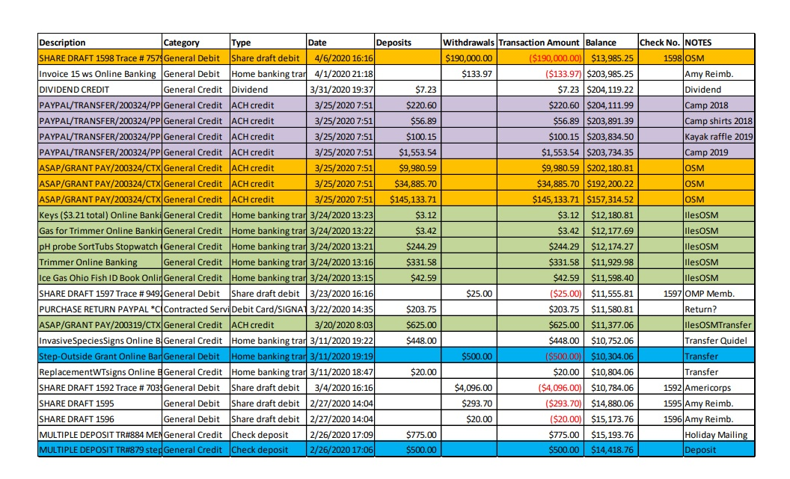
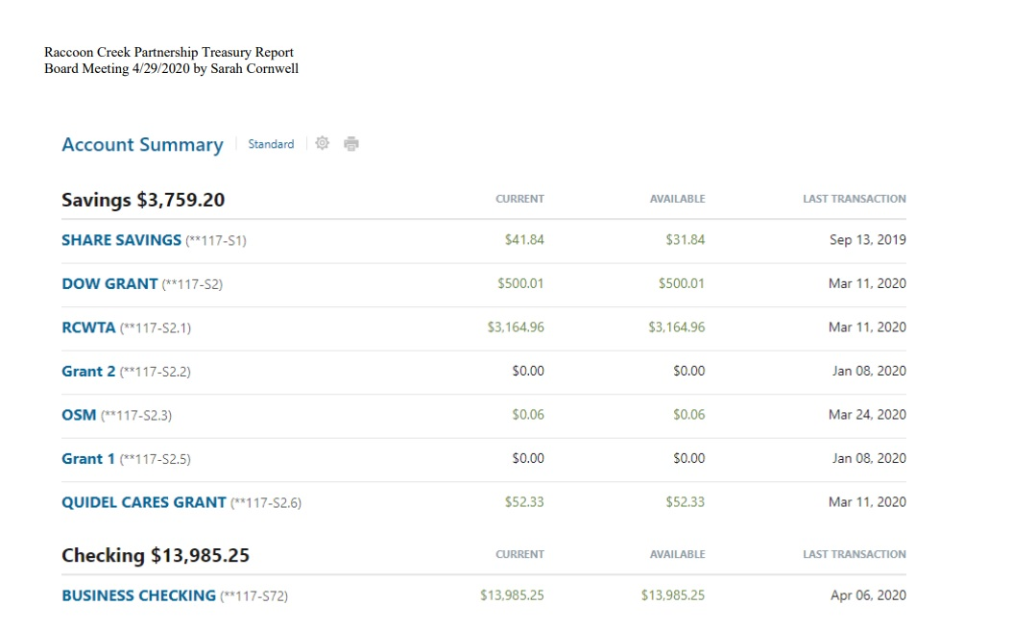
  - Sarah Maj and Sarie had a meeting (before social distancing!) about
    - Still in partial transition since Sarah Maj is not on account yet
  - Postcard filing of taxes
  - Ohio Charitable Law annual report filing is due May 15th
    - Sarie and Sarah Maj will try and do it together
    - Sarie and Sarah, figure out time to meet
  - Rural Action cashed check for AmeriCorp
  - OSM grant pass through
  - Purple was transfer from Paypal
- Water Trails
  - Tom Arbour joined meeting to chat about making Raccoon Creek a State-Designated water trail
  - Worked with Doug (predecessor to Tom), came down and gave presentation but it has been awhile
    - Main impediment was that we needed a corporate sponsor and sponsor had to promise $50,000 for maps and signs
    - Did a kickstarter campaign, raised over $3,000, student designed map and printed them on waterproof paper
    - Also wrote a grant to get signs made
  - Tom had background in GIS and in 2017, ODNR was told in revised code that need to map all trails. Role was to take over state water trail program and help designate water trails. Previously only worked with government organizations but since Tom took over, has been working with non-profits. Can do reimbursement grants (spend it first, then get reimbursed).
  - Like to have state logo on maps.
    - We can put stickers on the maps
  - What do we (RCP) still need that they can help fund?
  - Like to have evidence that the water trail supported by the community
    - Would need support from communities that the water trail goes through
      - Chris would be happy to work with those down in the Gallia county area
      - Tom can get us sample letters of support and letters of resolution
    - Private property concerns are usually an issue
    - We have a conservation easement in Gallia county
    - Attorney General rule is anyone paddling down a stream can get out on private property to get around an obstacle as long as continuing to go around
  - What is the requirement between put-ins/take-outs?
    - No more than 10 miles
    - There is a site towards the lower end of Raccoon Creek that is no longer accessible
  - What is the role of a sponsor?
    - Want to identify an organization that has a lot of buy-in. Request an MOU or OMA agreements. Trying to go to MOU model because want to make entire length of stream and designated water trail.
  - What does ODNR water trails fund?
    - Water trail signs and maps
    - Emergency hazard signs
      - Issue on private property
    - Haven’t funded yet but could: interactive maps
    - Could do bridge signage
  - ODNR has a paddling enhancement grant program
    - Get an extra 10 points in grant proposal because due to this meeting, we are now a proposed water trail
    - Also do by geography, trying to have one in each section of the state
  - We ran into problems with ODOT about signage on roads. Ran into difficulties with Division of Forestry and getting access points in a state forest.
    - Have been working with Forestry closely recently, maybe that relationship has changed.
  - What Tom usually recommends a workshop, an event where you have a couple speakers and he gives a presentation about the water trails. It’s a good kick off to get more people involved.
    - Example: Portage River trail
      - Had a mapping group
      - Had a safety group
      - Had a Education group
      - We have relations with all the soil and water districts in the counties that Raccoon Creek flows through.
        - Just have to find those niche groups
  - Ashley still up for spearheading this project
    - Be the person to take questions to Tom and relay information back to us
- Watershed Coordinator Update
  - Amy has still been able to do project maintenance on Raccoon Creek projects as well as Sunday and Monday Creek projects
    - Gone to Flint Run and Lake Milton, Pierce Run, East Branch
  - Scenic Rivers conversation:
    - Talked to Bob Gable
    - Very supportive of getting a scenic river in Southeast Ohio
    - Working on getting letters of support to send to Bob Gable
      - Not even specifically for Raccoon Creek, just for the area so they can send some money to support a program down here
      - Raccoon Creek meets most if not all criteria for scenic river
      - Could tag team and do both scenic river and water trail at the same time (do one letter)
    - AmeriCorps
      - Put proposal to Voinovich School and they agree to pay $13,000 of $18,000 for AmeriCorps for the next two years
      - Means RCP has to pay $5,000
      - Ashley and Kelly are both staying next year!
  - Ilesboro 319 grant, we are supposed to do a tour of Ilesboro as part of the grant, but obviously can’t in current situation.
    - We are going to do a virtual tour
    - Using story map, drone footage and photos
  - Doing story map of Raccoon Creek
    - Going to have an explorable map and you can jump site to site
    - Will have photos and information about each site
    - Have been compiling list of sites and information
    - AmeriCorps, do a call out on Facebook for pictures of each sites that we don’t have pictures for (maybe some of the historical sites)
    - Chris has pictures of Tycoon lake and surrounding areas
    - There are some photos on watersheddata.com that Sarie took
    - Get something out in Conservation District newsletters?
    - Nora, send out list of sites to board
- AmeriCorps Education Update
  - River Sweep rescheduled for August 15th at Buckeye Furnace
  - Family Outdoor Day rescheduled for June 28th? CANCELLED
  - Kelly visited Moonville and took photos and video, plan to do a doser video
  - Both have been doing social media stuff
    - Whole week of Earth Day stuff
  - Summer Camps CANCELLED
    - Contingency plans
      - None yet but keep hoping things get better
      - Rural Action hasn’t made any contingency plans either
    - Raccoon Creek Outfitters is attempting to open this weekend
  - Step Outside Grant
    - FOD was supposed to be May 30th, now pushed back to June 28th
      - Our Step Outside Grant has to be spent by the end of June, they will not be extended
      - Sean said we can use on supplies but can’t pay for food now to get the food at the end of June
        - Spend money out now on other stuff. If we don’t spend it and event gets cancelled, we our out that money
        - AmeriCorps are writing another Step Outside grant for next fiscal year.
        - We got two step outside grants, the later one (that hasn’t come in), was supposed to be used for archery.
        - Can spend the one we have on archery supplies and use the second grant on food for FOD (but can’t spend until July 1st).
      - Nora moves to use the step outside grant we currently have on archery supplies.
      - Chris seconds
      - All approve and motion passes
- Fundraising
  - Still need to think about fundraising
  - T-shirt and hat orders
    - Can put in t-shirt orders any time
    - Putting in hat orders (with RCP logo)
      - $15 hat, khaki colored
      - Kelly will be ordering about 20
- New Business/Announcements/Next Meeting
  - Chris got accepted as part of the Bee survey
    - Bee survey: Surveying bees from first frost to last frost
  - Next meeting May 27th at 6:30 PM, probably a Zoom meeting again
  - Meeting adjourned at 8:28 PM

